***INFORMATICS PRACTICES PROJECT***

*PYTHON*

**CAR BOOKING SYSTEM**

***SESSION 2020-21***

***SUSHILA BIRLA GIRLS SCHOOL***

**NAME**- SHREYA SINGH

**AISSCE ROLL NO**-

**Certificate**

This is to certify that Shreya Singh of class XII C2 of Sushila Birla Girls’ School has successfully completed the project entitled ‘’ ‘’ under the guidance of Mrs Chandrima Ghosh during the academic session 2020-21 as per the guidelines issued by Central Board of Secondary Education for AISSCE 2021.

Mrs Chandrima Ghosh External

**INDEX**

|  |  |
| --- | --- |
| Sl No. | DESCRIPTION |
| 1. | Introduction |
| 2. | Hardware and Software |
| 3. | Technical Design and User Interface |
| 4. | Source Code |
| 5. | Output |
| 6. | Limitation |
| 7. | Bibliography |

**ACKNOWLEDGEMENT**

I would like to thank my Informatics Practices teacher Mrs. Chandrima Ghosh, for giving me an opportunity to learn various functions of python and helping all along the way through this project. I would also like to thank CBSE for giving me the opportunity to work with this project and gain practical knowledge of an application made using python.

Lastly, I would like to thank my parents for helping me complete the project on time by providing me with useful ideas and help relating to it.

**INTRODUCTION**

This project is designed so as to be used by Taxi Booking Company specializing in Booking cars (Taxis) for short distance ride to customers. It is an online system through which customers can book a hassle-free ride within minutes.

This program helps the user to choose any membership according to their preference, convenience and budget as it provides in hand information about everything that the user might be interested while getting a membership.

The program also lets it’s user get an insight about the company as it also provides the ‘reports’ which the user can check if interested.

**Hardware and software**

**HARDWARE REQUIREMENTS:**

1.Dekstop / Laptop

2.Printer

3.Keyboard

4.Mouse

5.Storage Device

**SOFTWARE REQUIREMENTS:**

1.Operating System-Windows10

2.Notepad

3.Ms Word

4.Python

5.MYSQL

**Technical DESIGN AND USER**

**INTERFACE**

Data structure – MYSQL

**1.Membership Types**

|  |  |  |
| --- | --- | --- |
| **NAME** | **DATA TYPE** | **FUNCTION** |
| Type | char[ ] | To save the types of membership. |
| Price | Int[ ] | To save the price of each membership. |
| Tcode | varchar[ ] | To save the code of  membership types. |
| Validity | varchar[ ] | To save the maximum no. of months these memberships are valid. |
| Maximum_people | int[ ] | To save the maximum no. of people allowed at one membership without extra cost. |

**2.Members**

|  |  |  |
| --- | --- | --- |
| **NAME** | **DATA TYPE** | **FUNCTION** |
| Name | Char [ ] | To save the names of the members. |
| Age | Int [ ] | To save the age of the members. |
| Gender | Char [ ] | To save the gender the of members. |
| Contactno | Int [ ] | To save the contact no. of the members. |
| Email_id | Varchar [ ] | To save the email-id of the members. |
| Membership | Char [ ] | To save the types of membership of the members. |
| Member_id | Int [ ] | To save the member-id of the members. |

**3.Cars**

|  |  |  |
| --- | --- | --- |
| **NAME** | **DATA TYPE** | **FUNCTION** |
| Car_Type | Char [ ] | To save the types of cars. |
| Fare | Char [ ] | To save the fares |
| Boarding | Char [ ] | To save the boarding stations |
| Destination | Char [ ] | To save the drop locations |

Data structure – Data frame

**1.Membership Preferences**

|  |  |  |
| --- | --- | --- |
| **NAME** | **DATA TYPE** | **FUNCTION** |
| Membership Type | Str [ ] | To save the membership types |
| Popularity (in %) | Int [ ] | To save its popularity |

**2.Profit Earned**

**Yearly:**

|  |  |  |
| --- | --- | --- |
| **NAME** | **DATA TYPE** | **FUNCTION** |
| Years | Int [ ] | To save the years of operation |
| Profit Earned (in lakhs) | Int [ ] | To save the profit earned in those years. |

**Monthly:**

|  |  |  |
| --- | --- | --- |
| **NAME** | **DATA TYPE** | **FUNCTION** |
| Months | Str [ ] | To save the months of a years. |
| Profit Earned (in lakhs) | Int [ ] | To save the profit earned in those months. |

**3.Car Preferences**

|  |  |  |
| --- | --- | --- |
| **NAME** | **DATA TYPE** | **FUNCTION** |
| Car Type | Str [ ] | To save the membership types |
| Popularity (in %) | Int [ ] | To save its popularity |

**BIBLIOGRAPHY**

**Books**

Informatics Practices - Sumita Arora

(Class 11 and 12)

# 

# All In One Informatics Practices CBSE – Arihant

**References**

[www.geeksforgeeks.org](http://www.geeksforgeeks.org)

[www.stackoverflow.com](http://www.stackoverflow.com)

[www.github.com](http://www.github.com)

**LIMITATION**

The program has the following limitations:

* The program does not takes any user

inserted location, it has to be chosen

from the given options.

* The user will not be able to know much

about the application as the program does

not provide any history or reliable

information about it.

* The project does not contain any feedback

reception where customers/members can

file their query or report any issues.

* The program does not print the receipt

after booking a ride.

**SOURCE-CODE**

**Import function:**

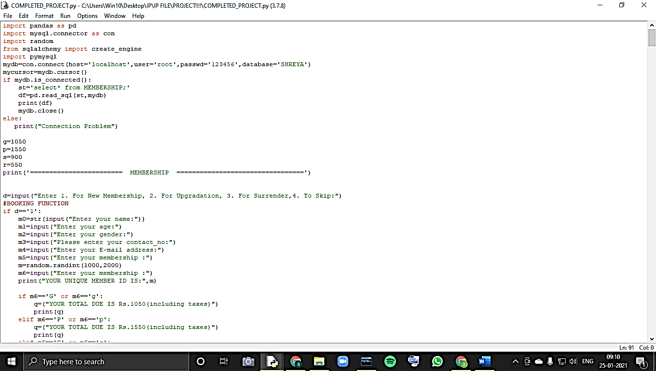

**MEMBERSHIP: Booking function:**

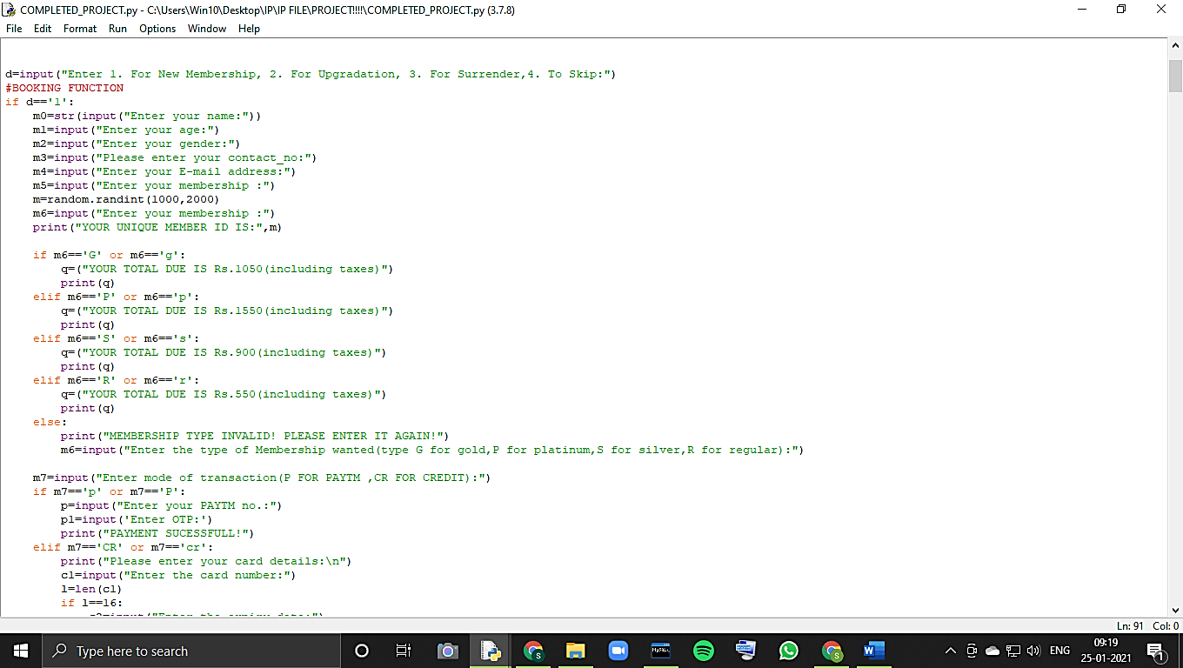

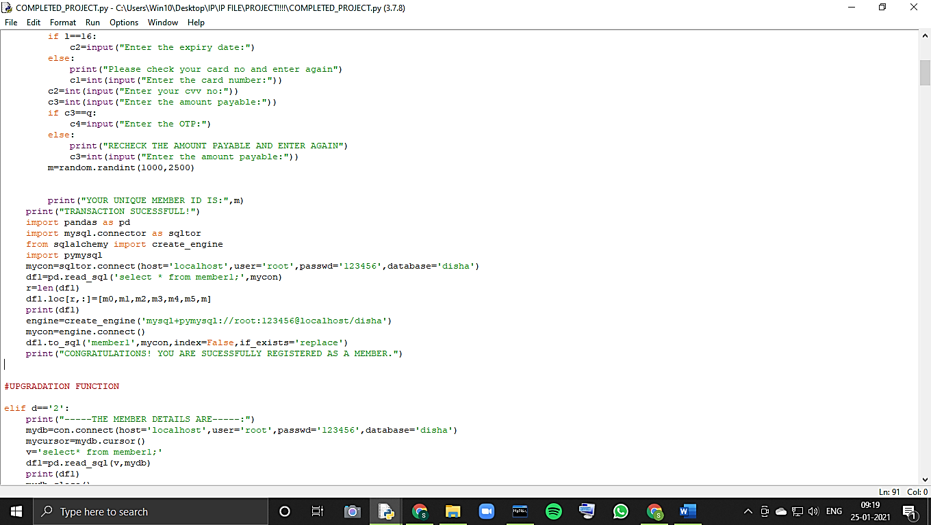

**Upgradation function:**

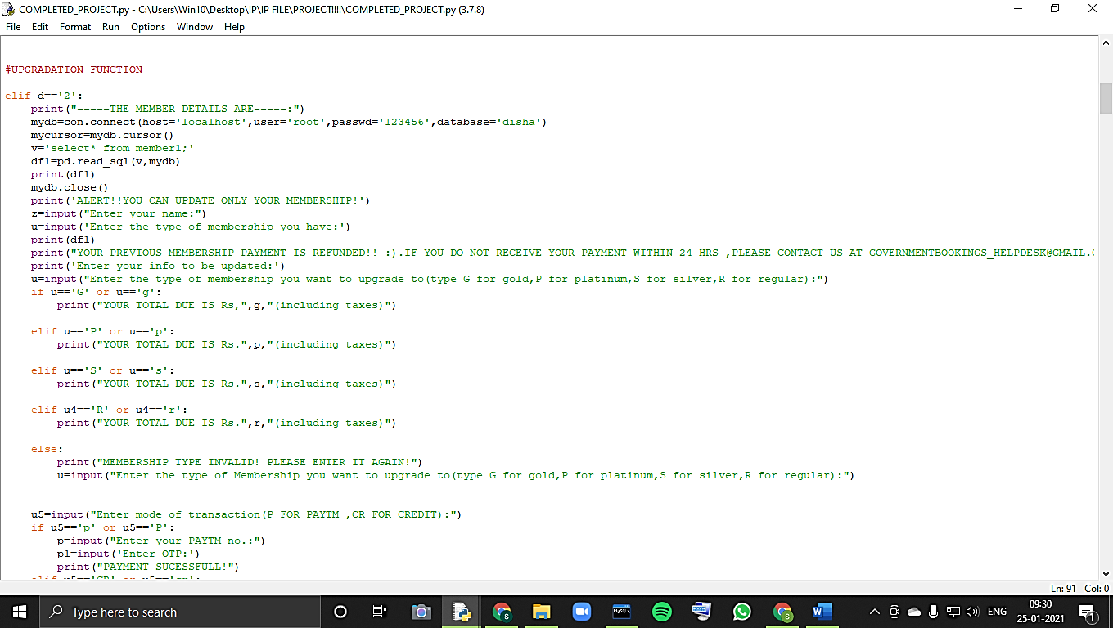

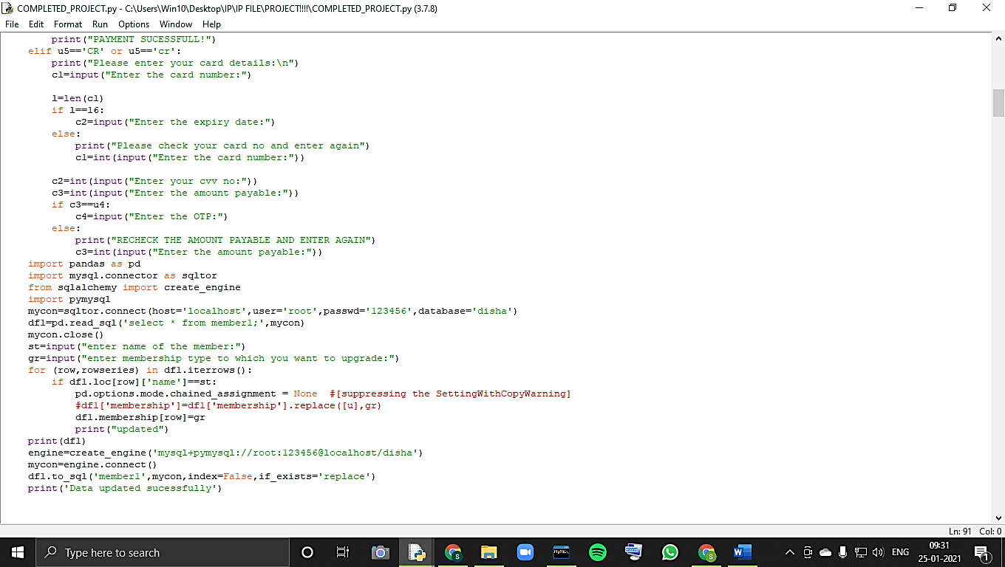

**Cancellation function:**

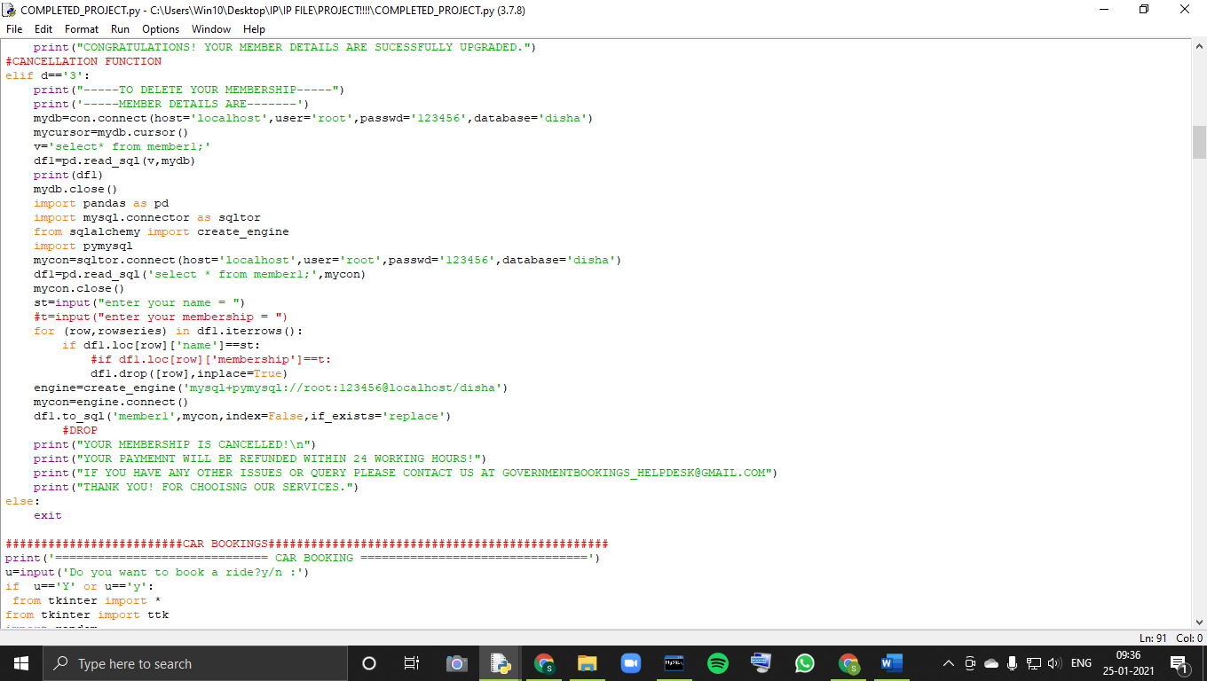

**CAR BOOKING:**

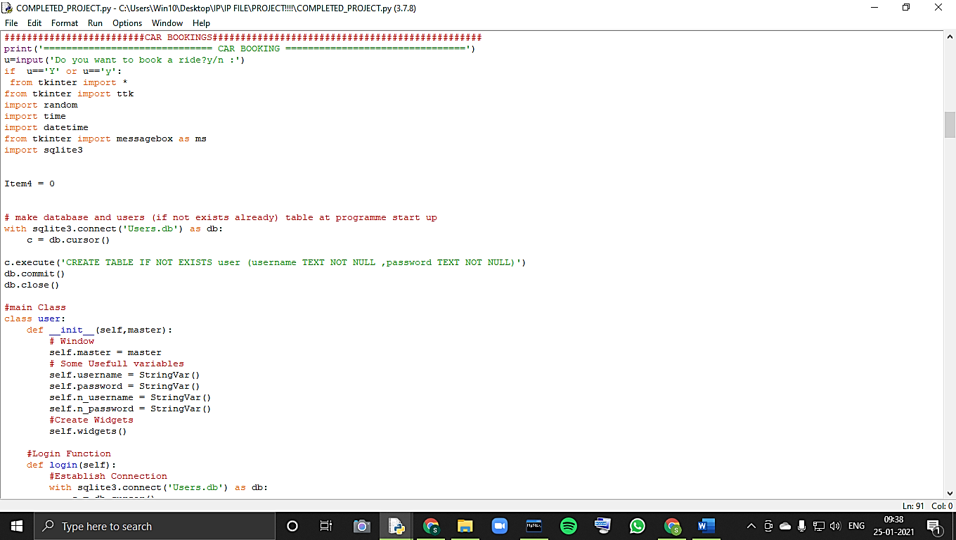

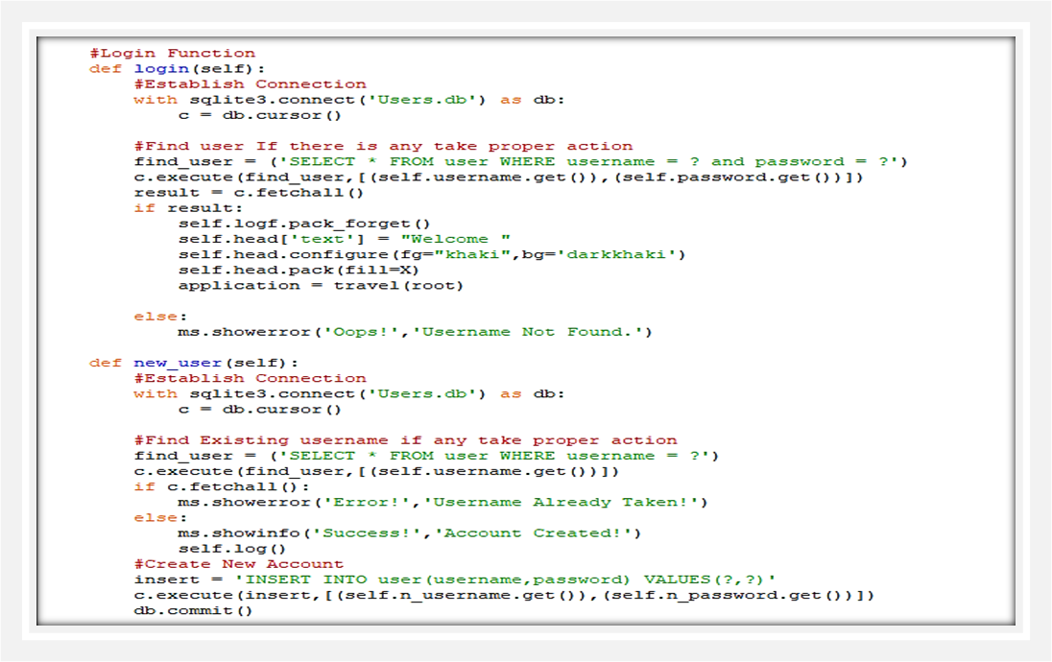

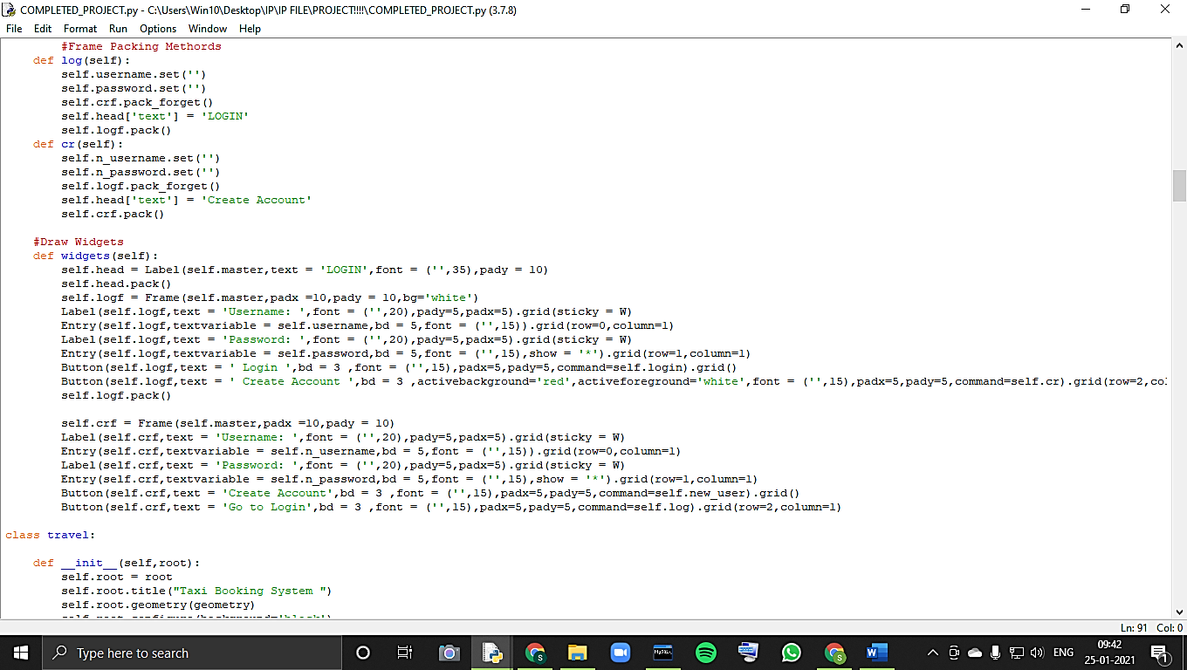

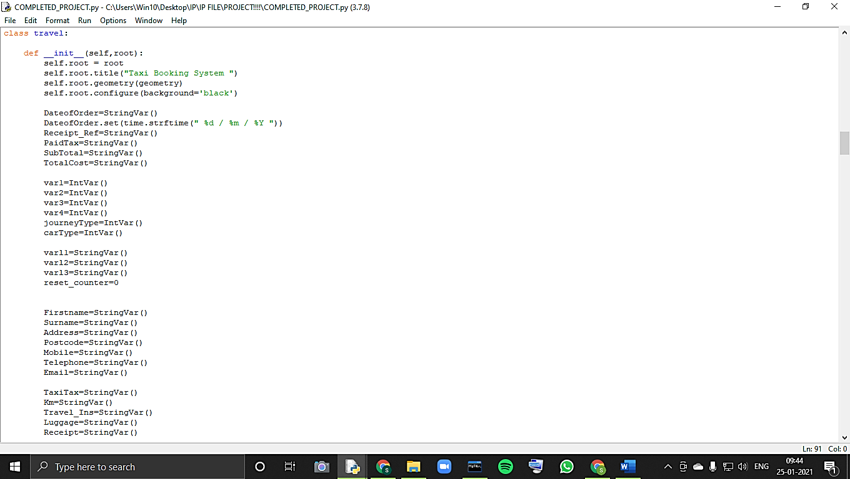

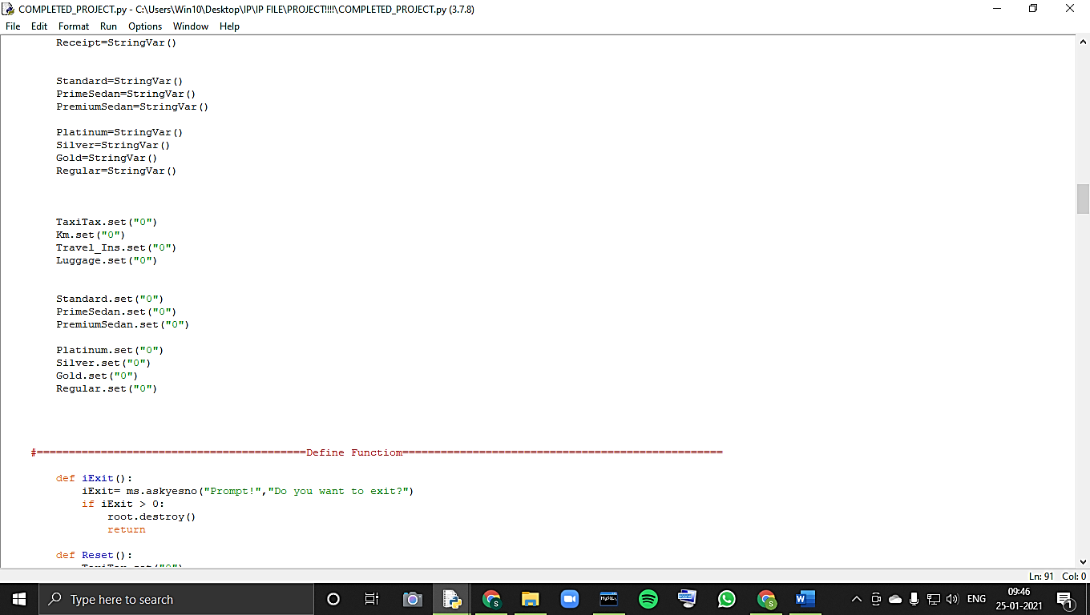

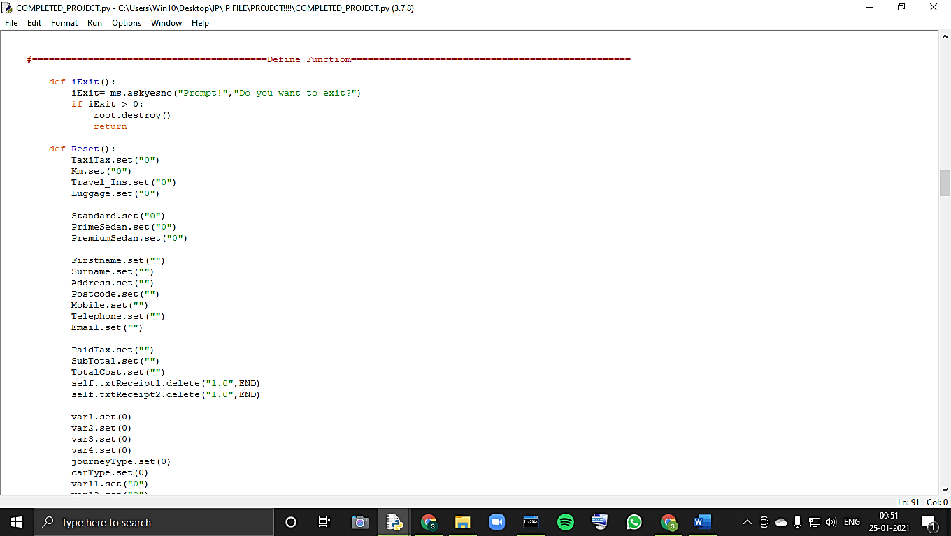

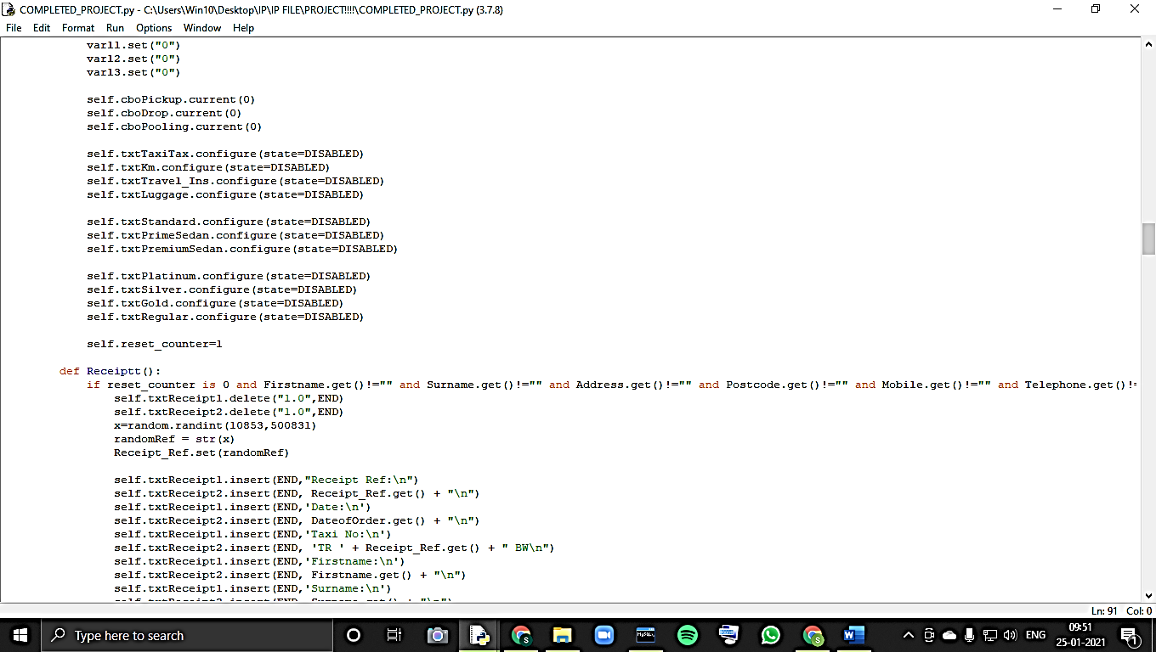

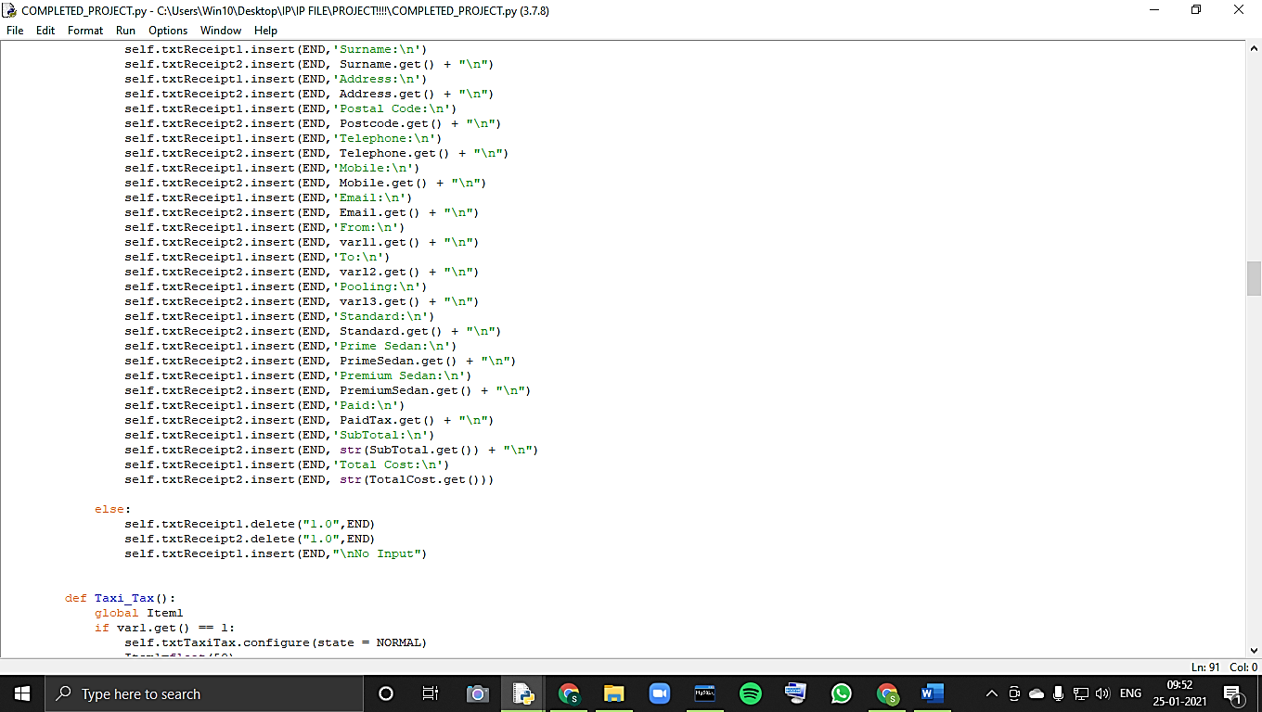

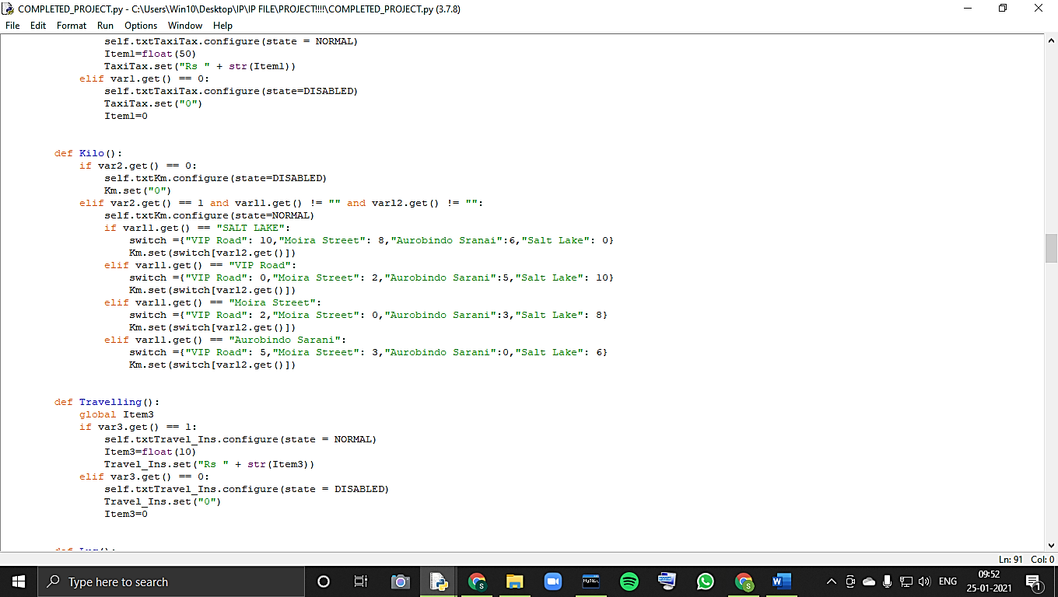

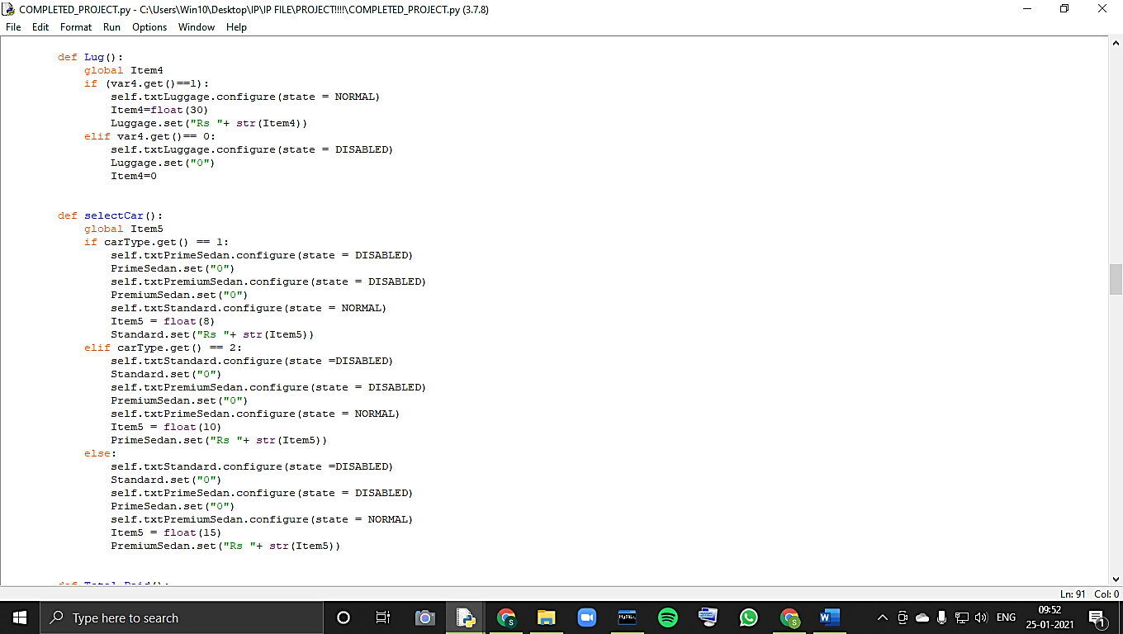

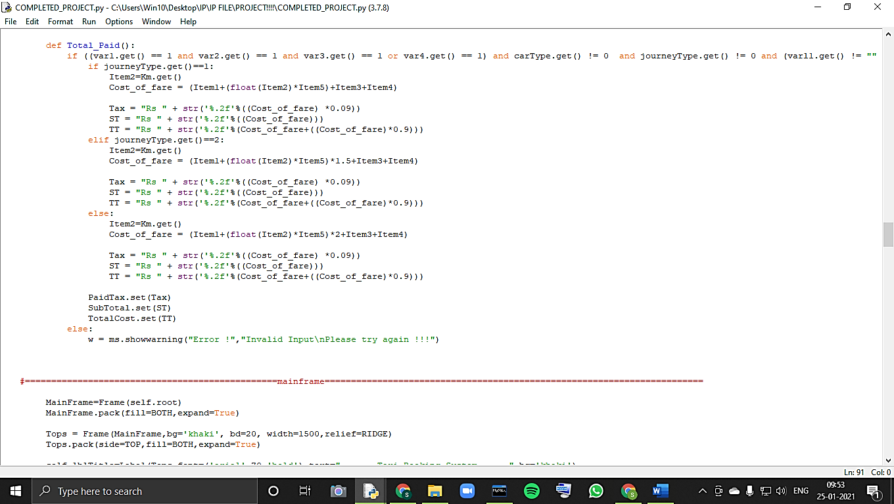

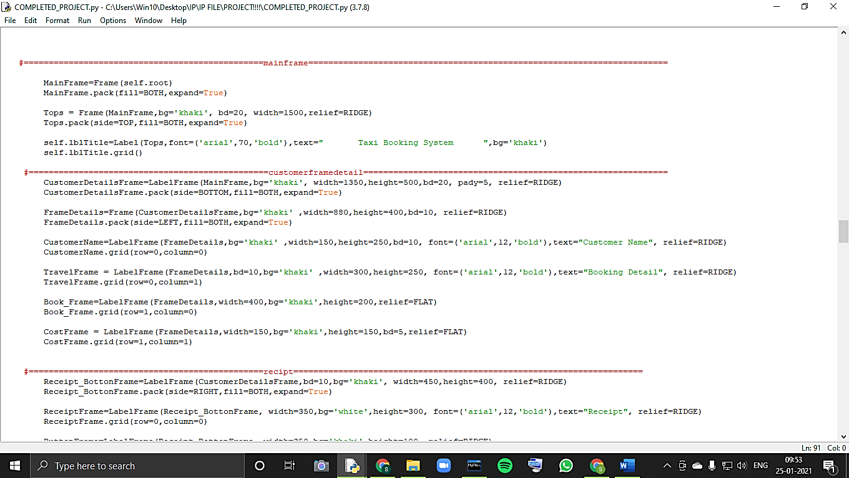

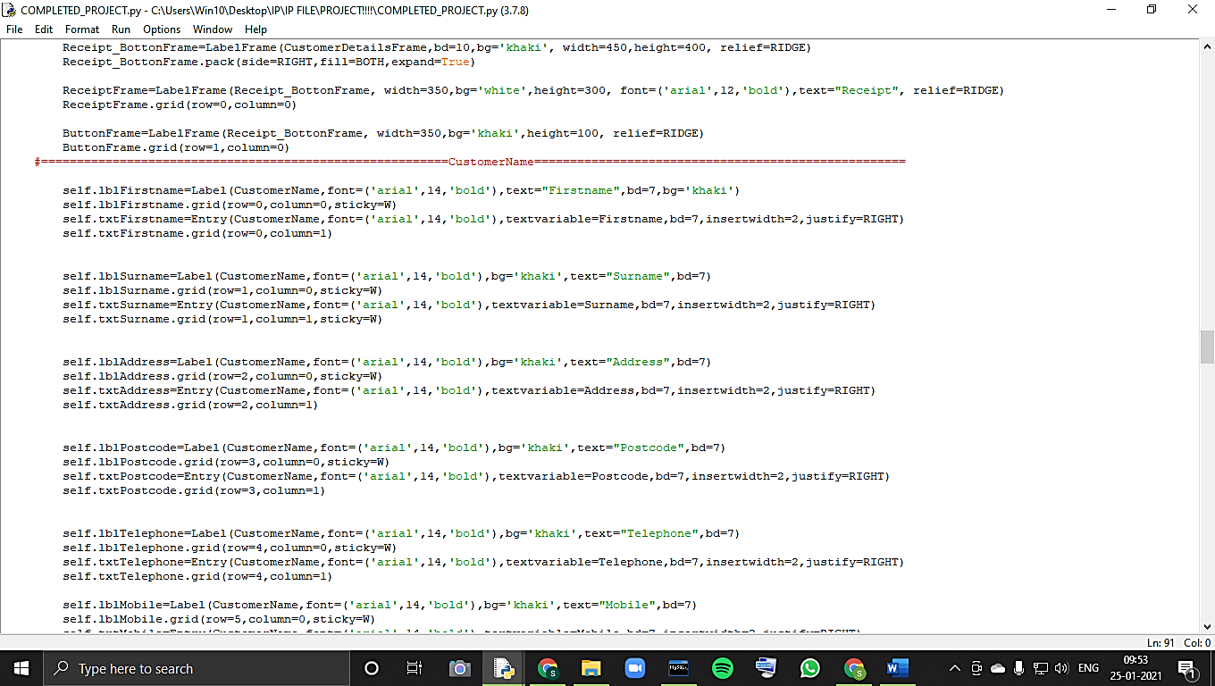

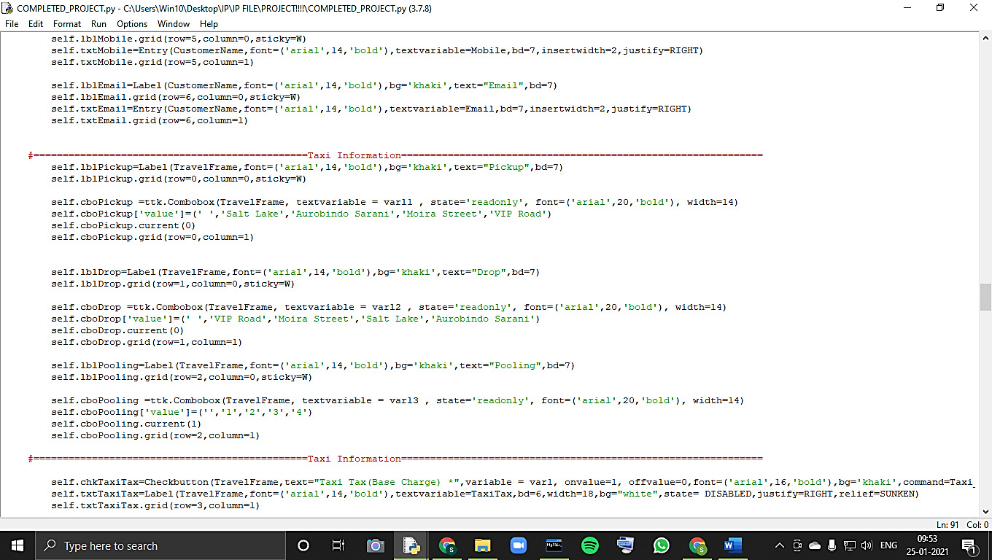

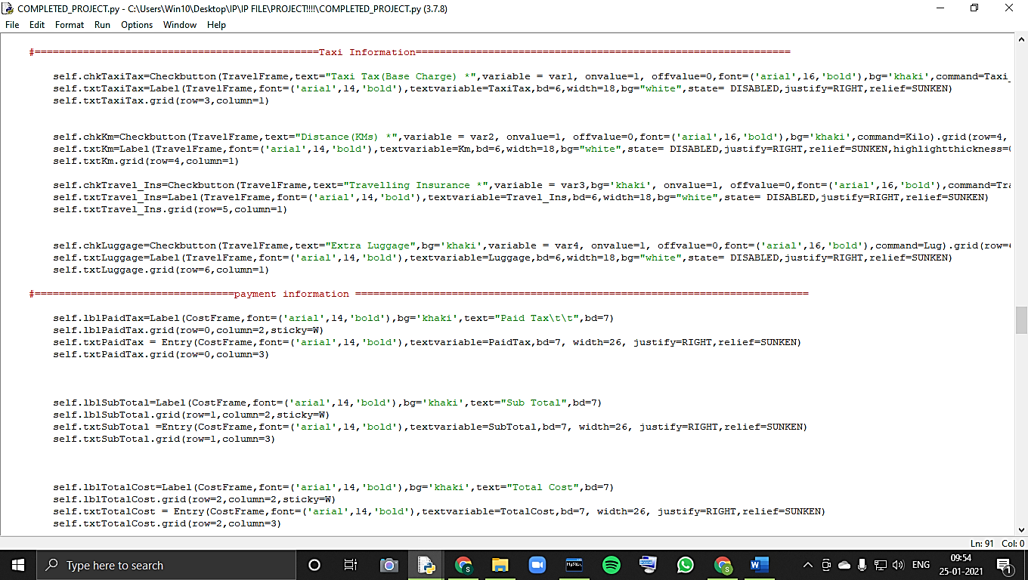

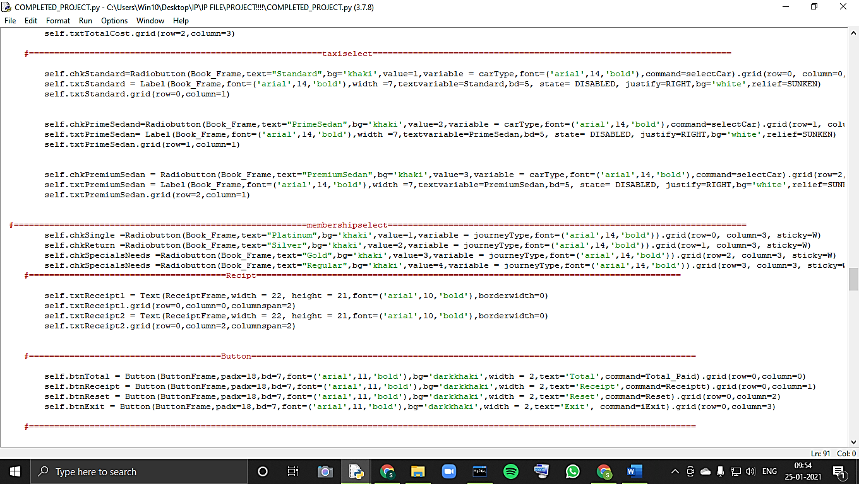

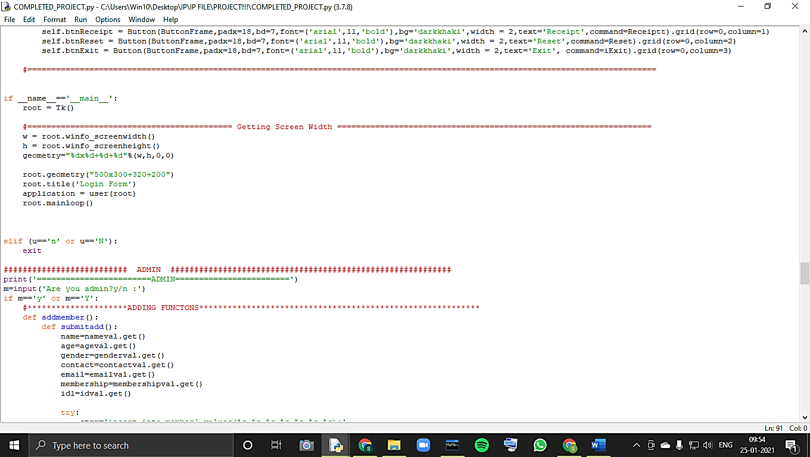

**ADMIN:**

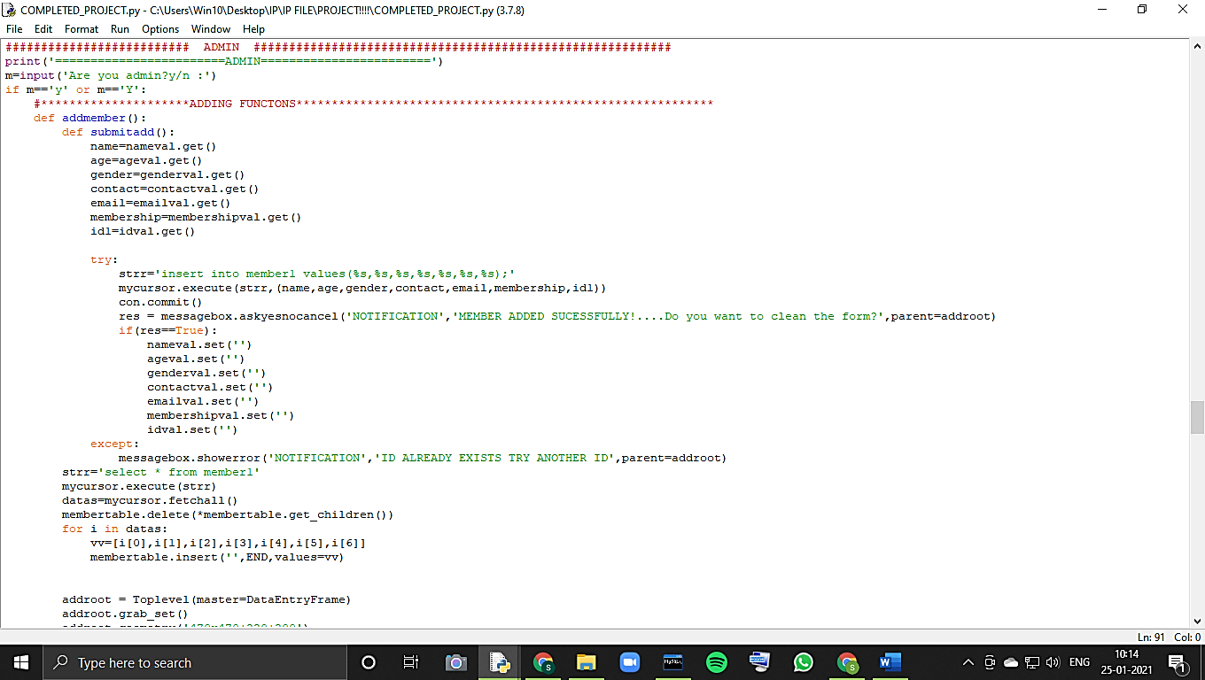

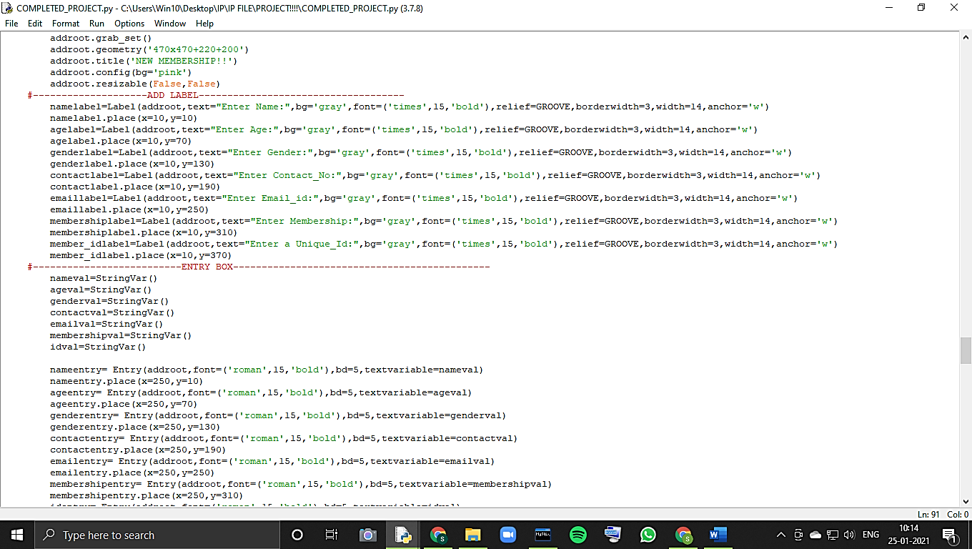

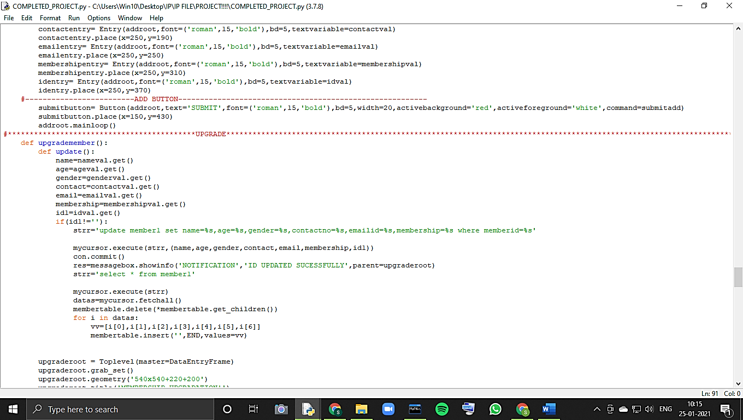

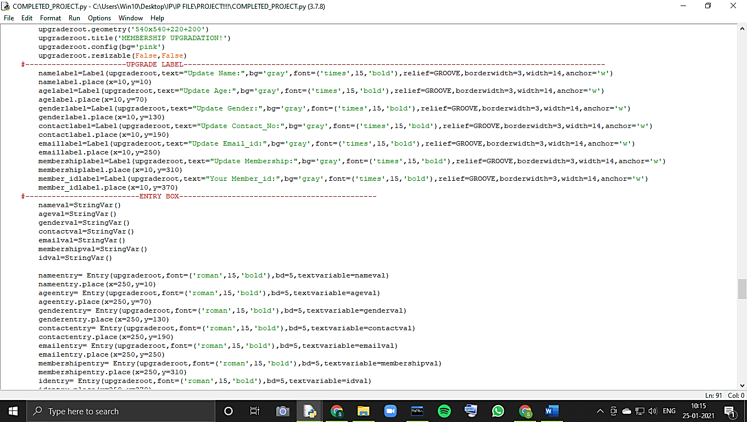

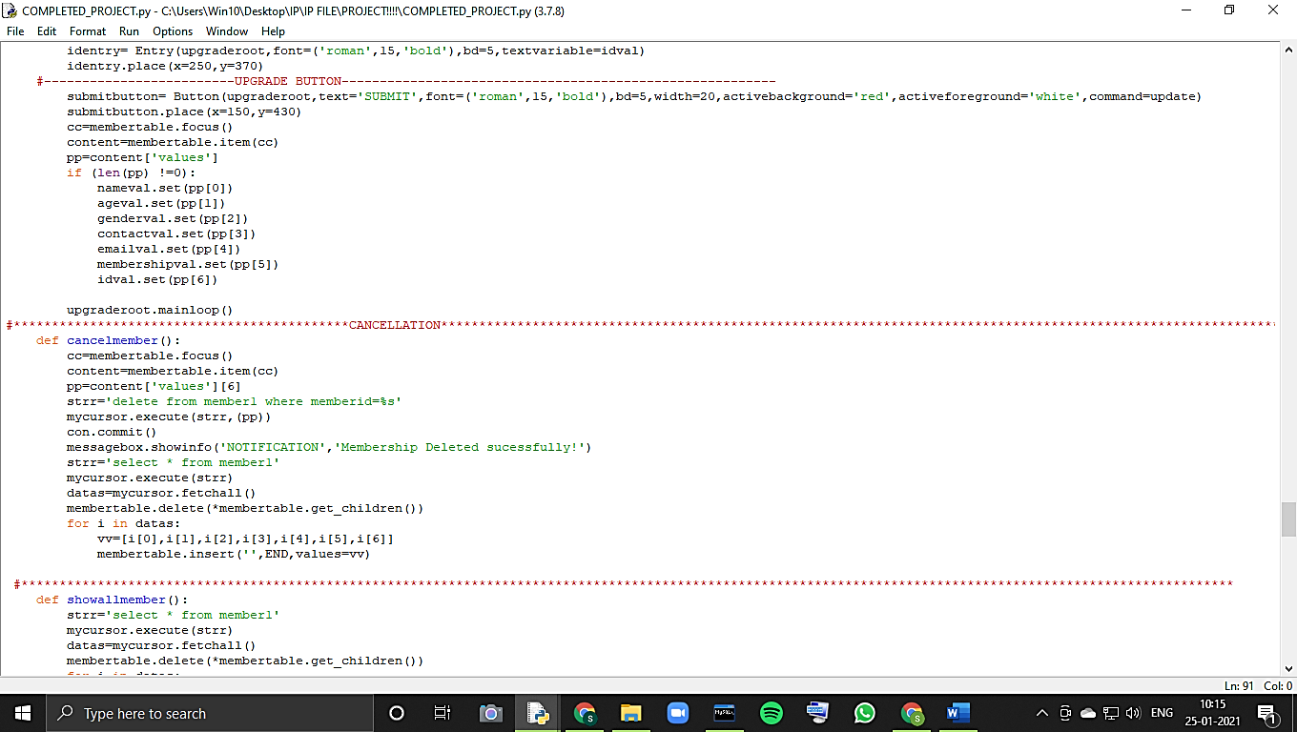

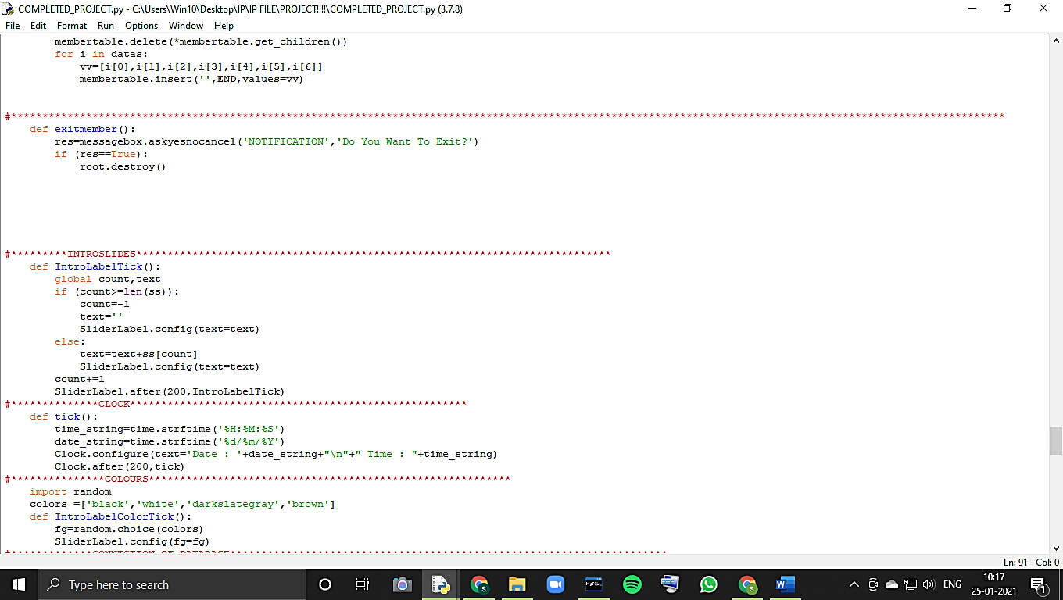

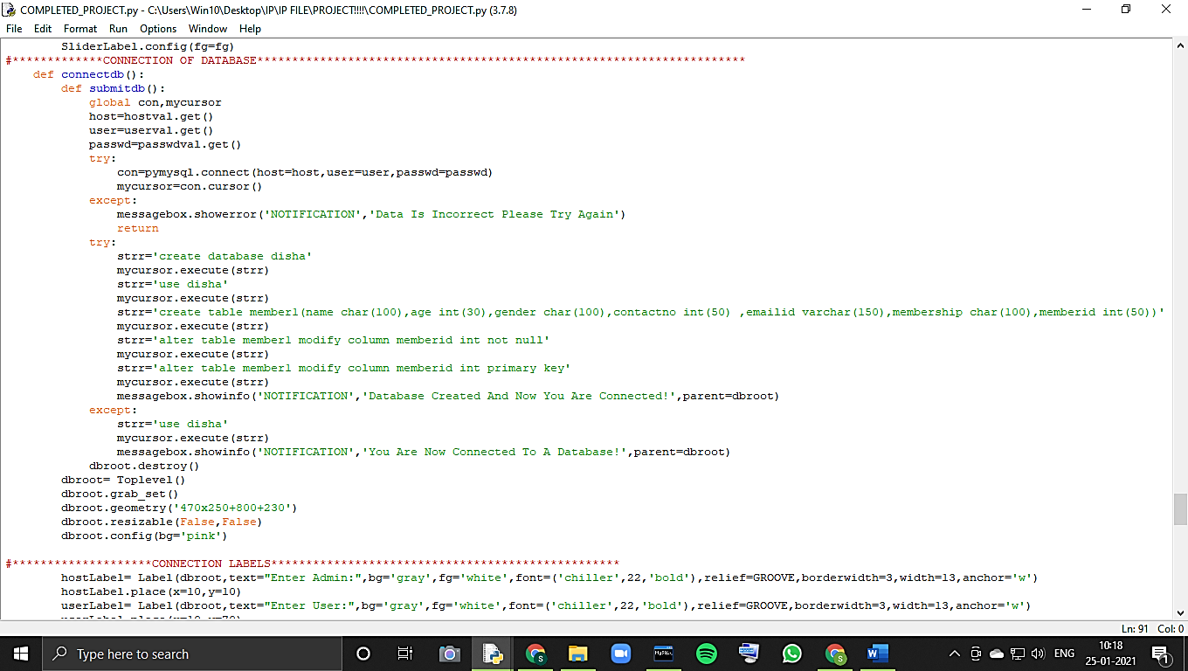

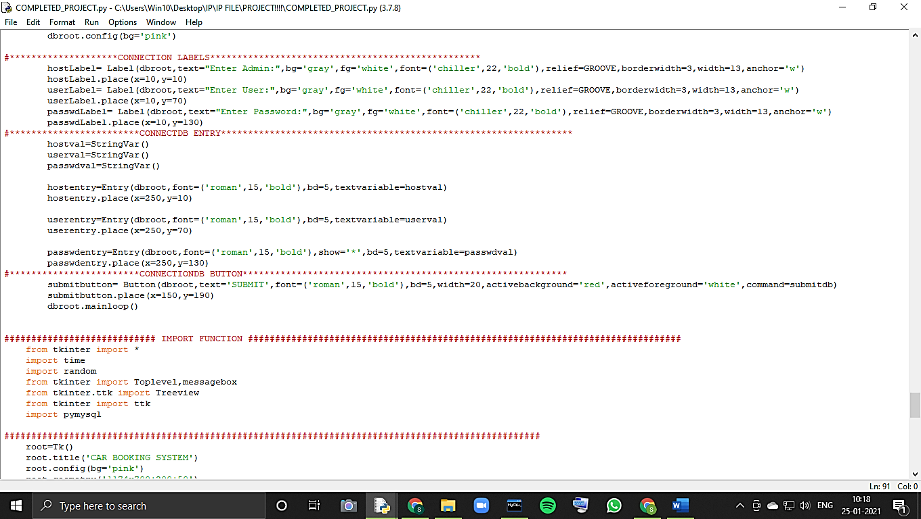

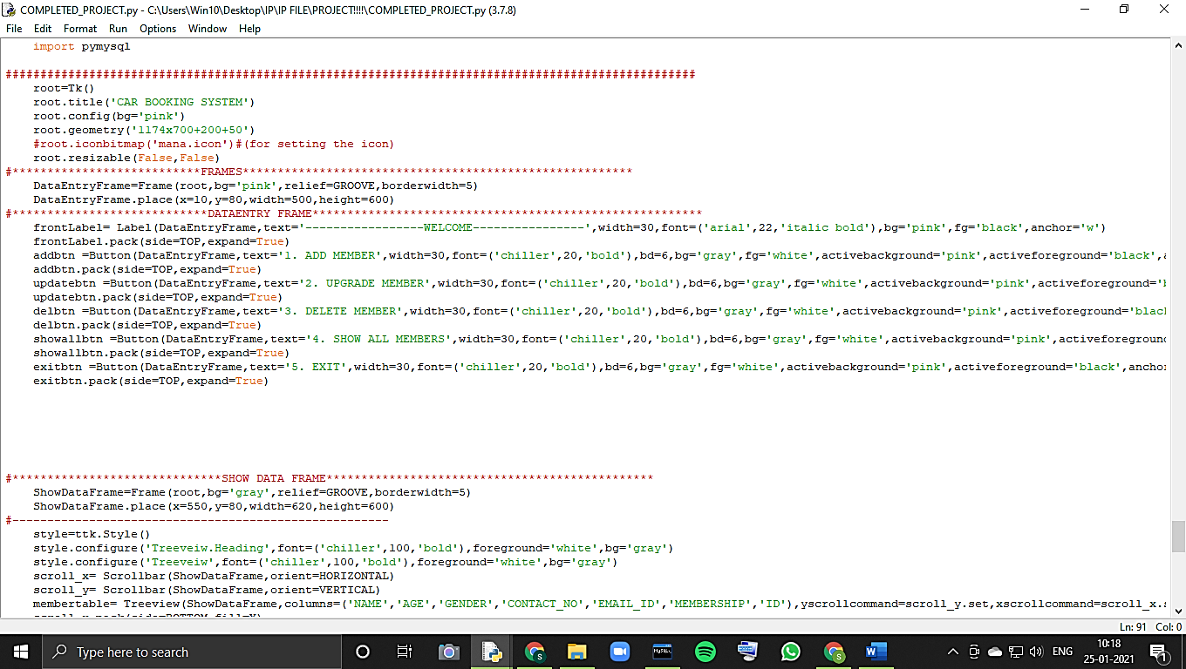

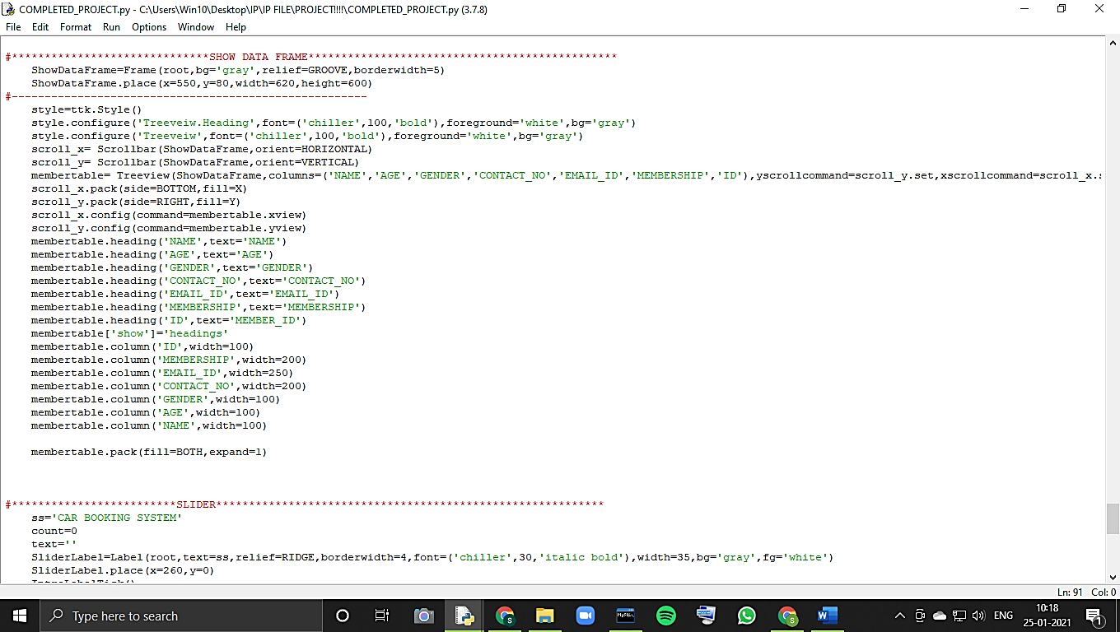

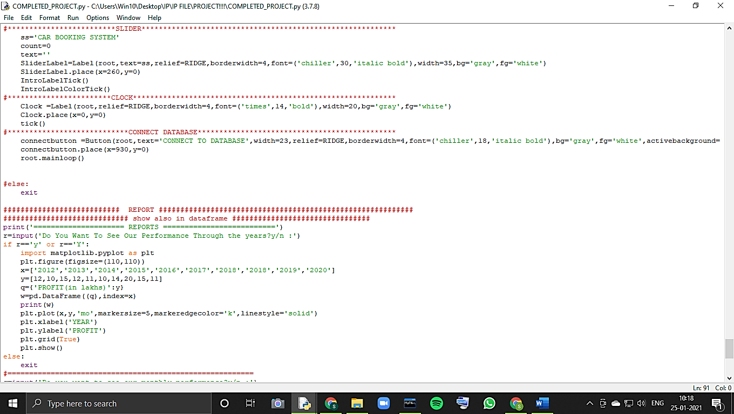

**REPORTS:**

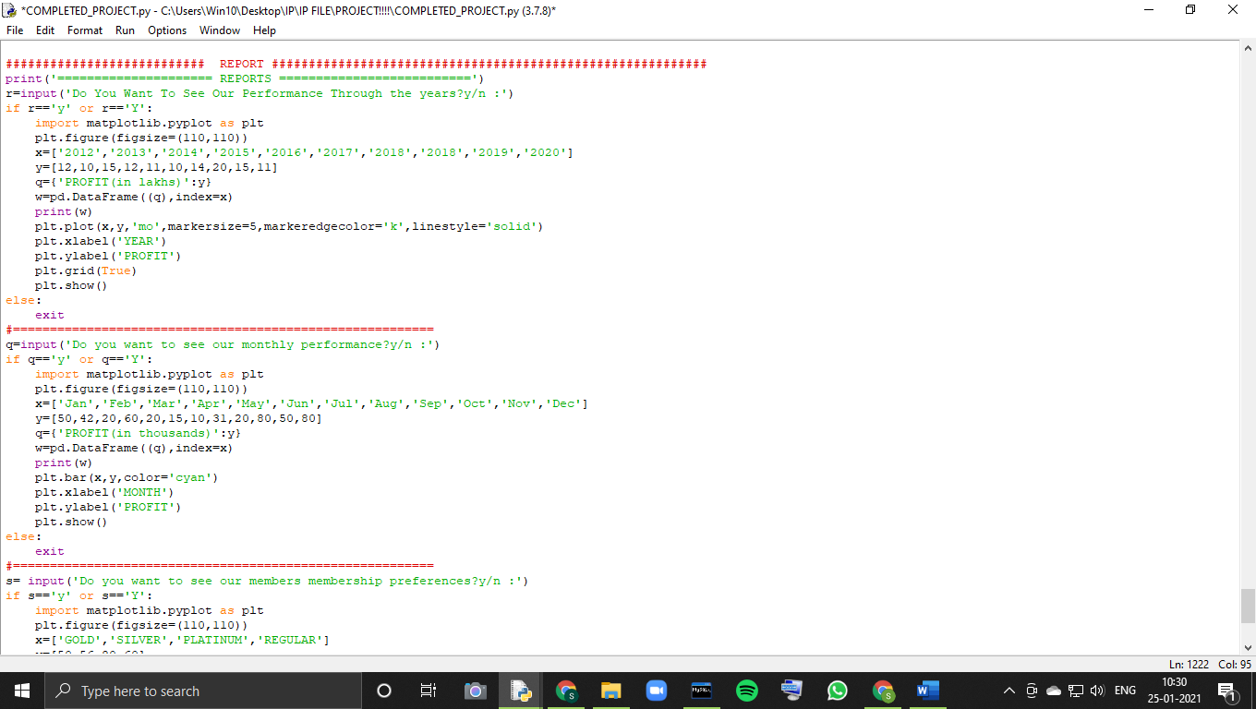

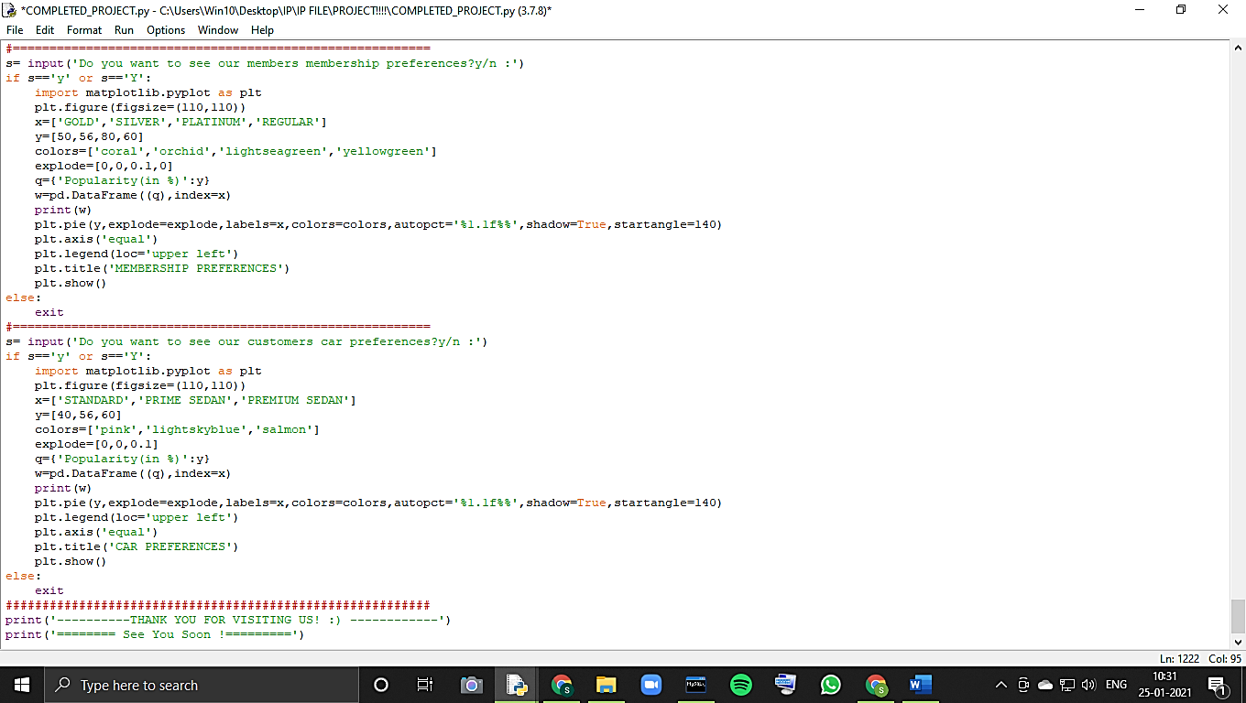

**USER-INTERFACE**

**Asking the user whether they want membership or not:**

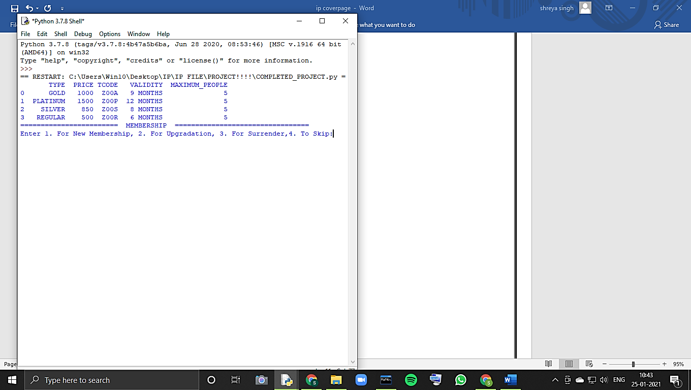**If user wants to take a membership:**

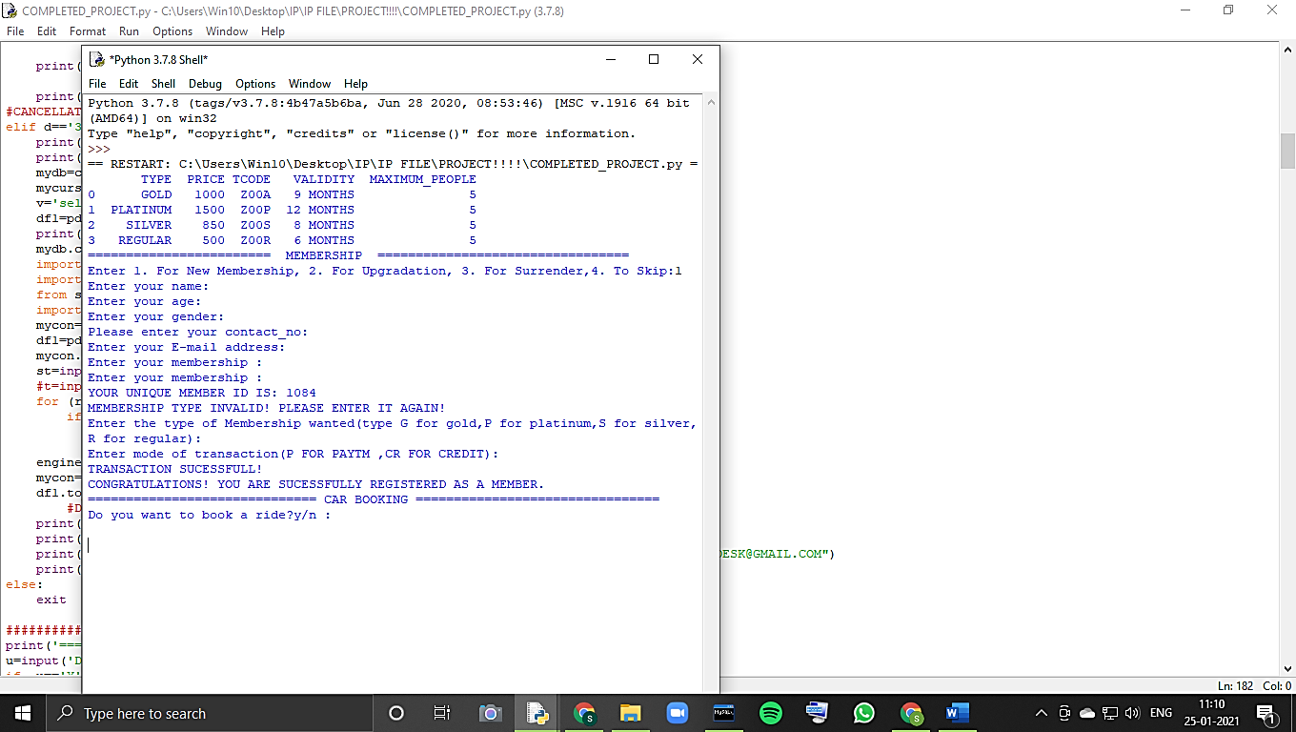

**If user wants to upgrade his existing membership:**

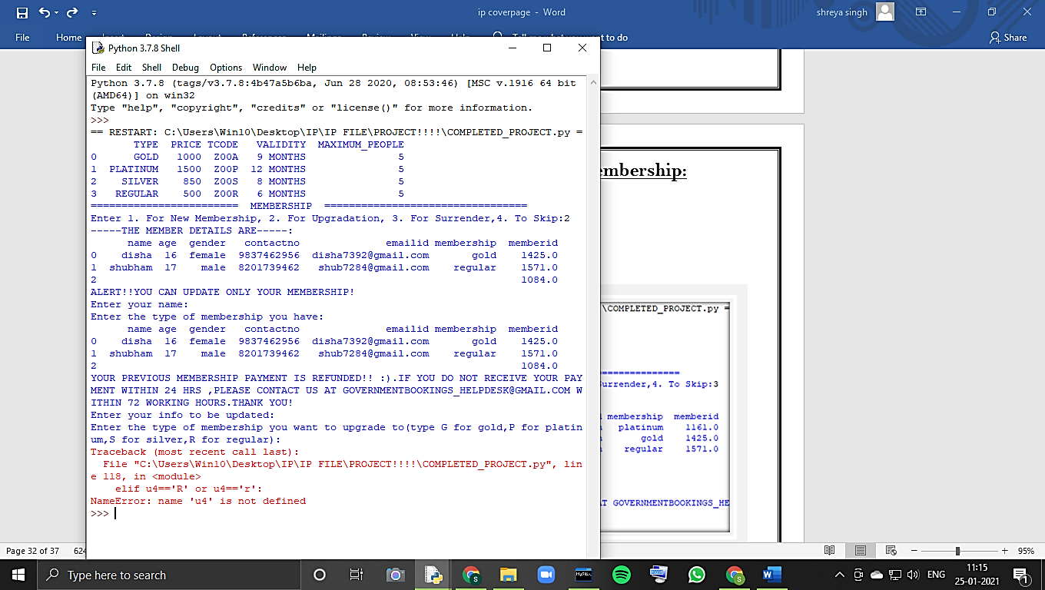

**If user wants to cancel it’s membership:**

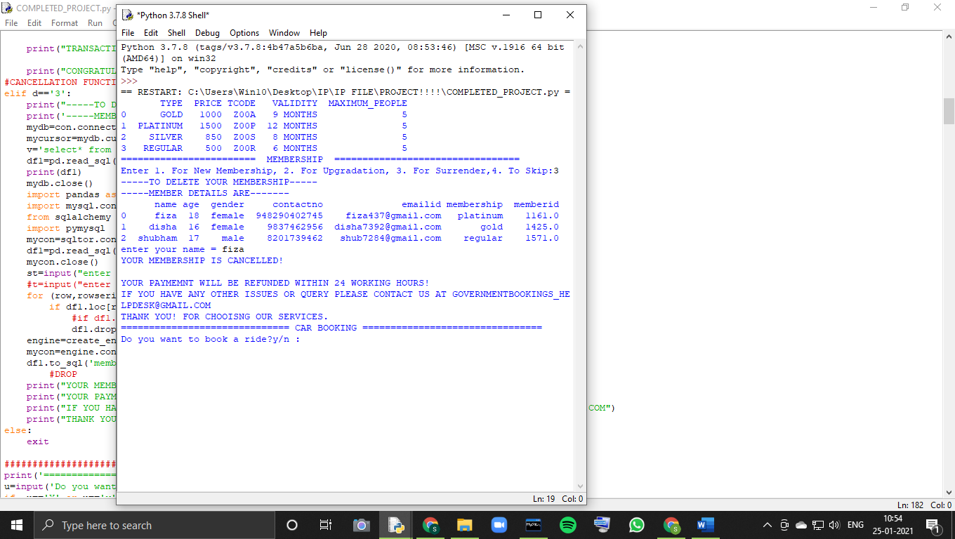

**If the user doesn’t want to do anything related to membership:**

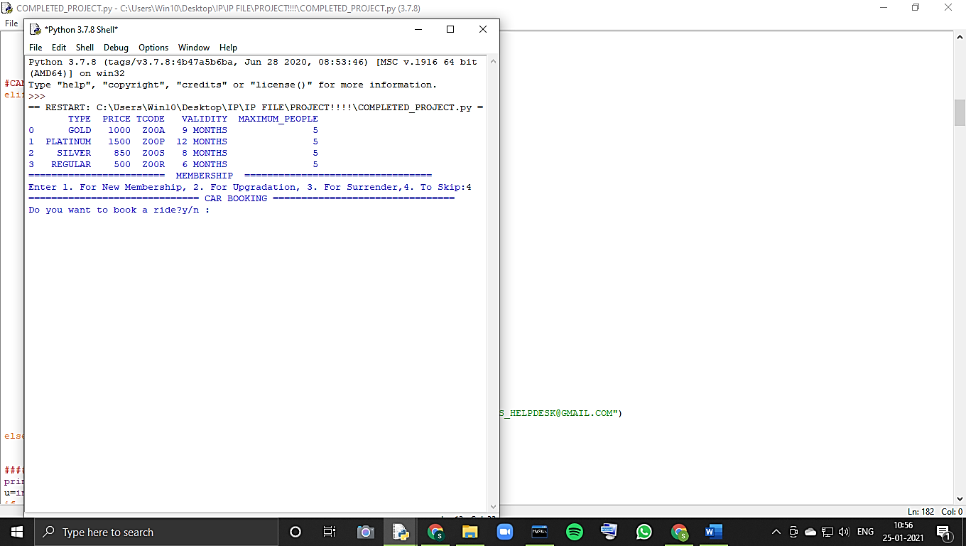

**When the user wants to book a ride:**

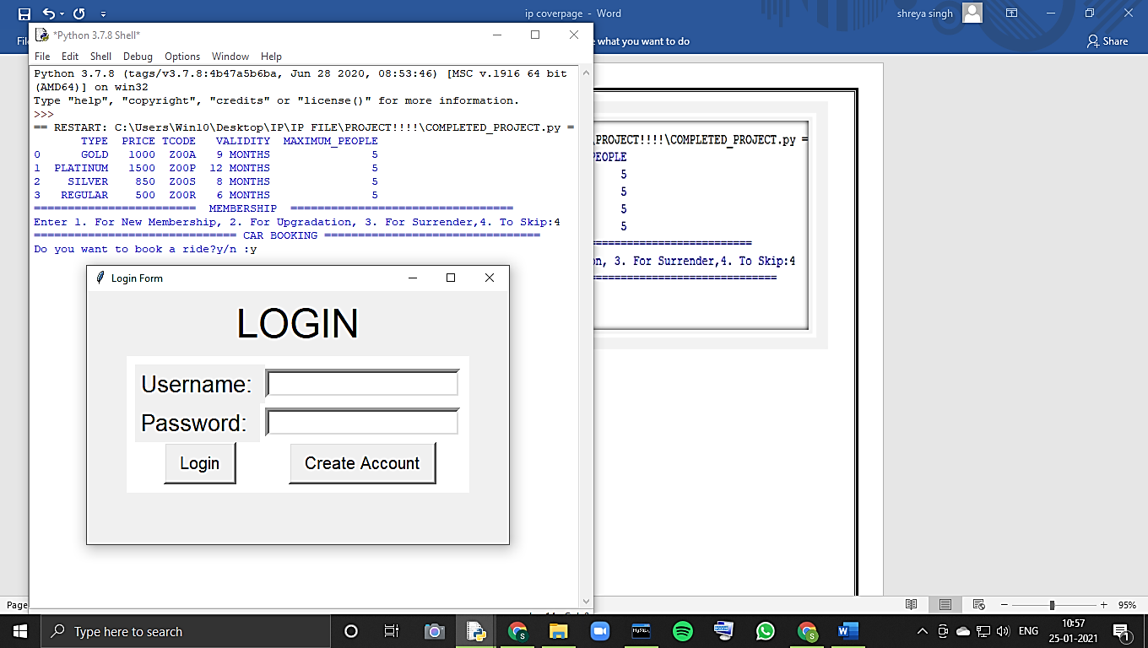

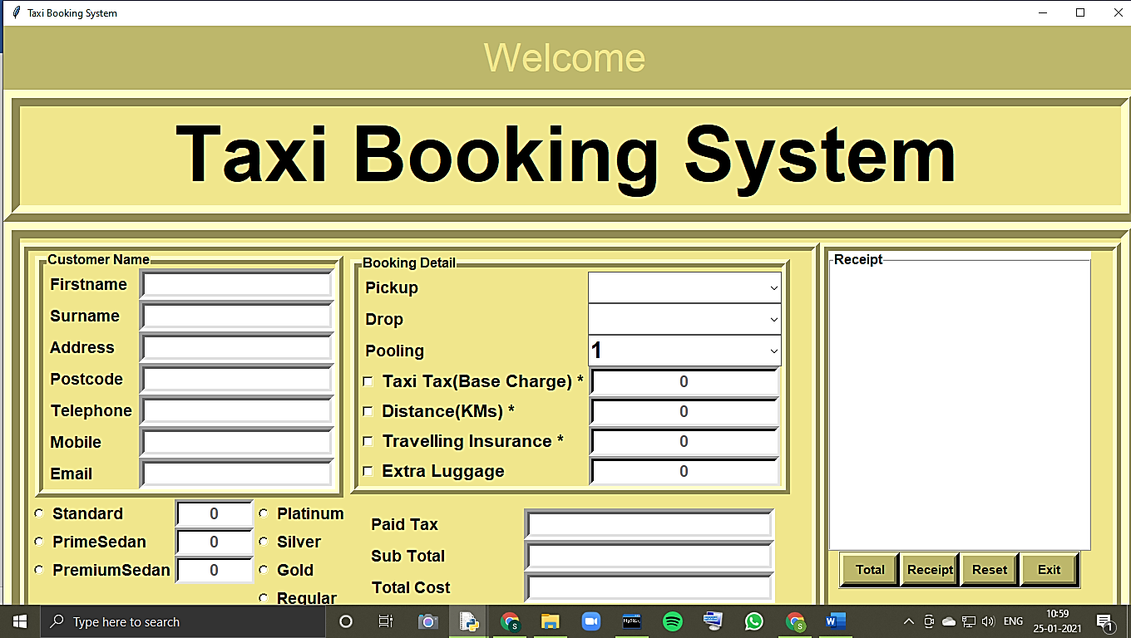

**When admin wants to upgrade its records:**

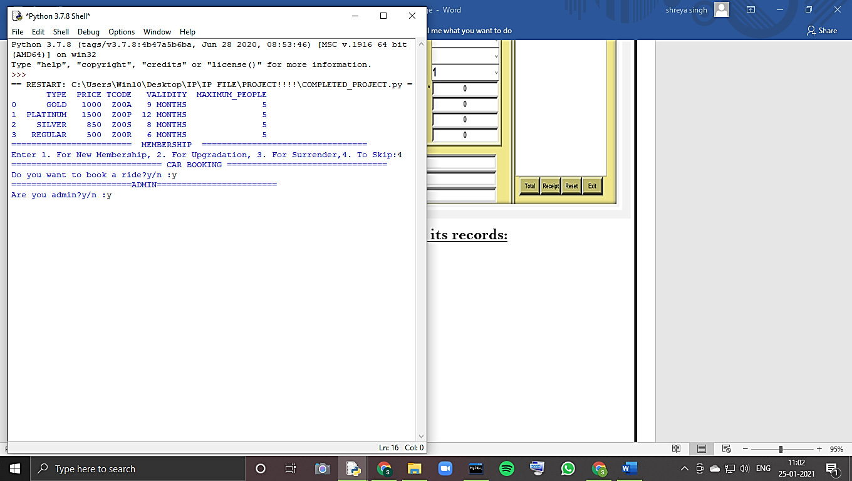

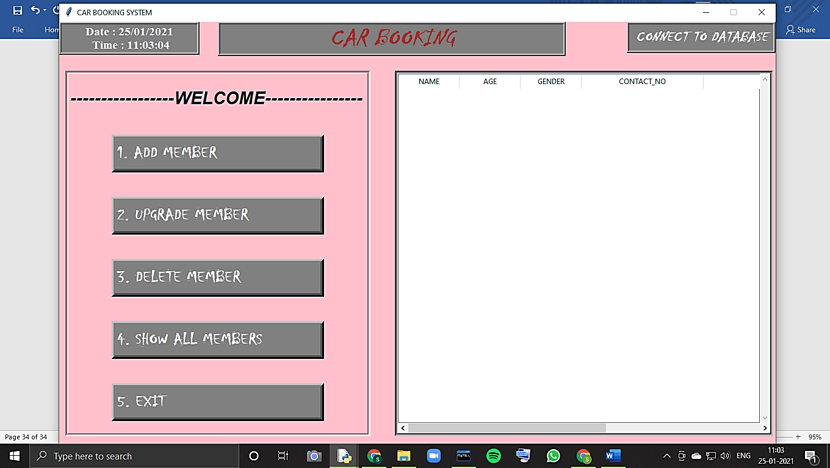

**When the user wants to see previous records to the company:**

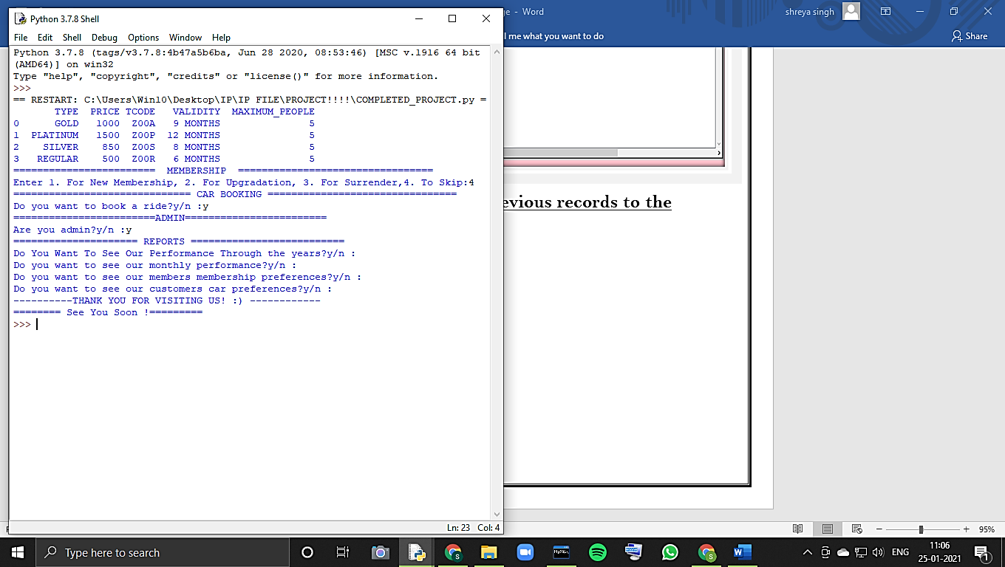

**output**

**If user want to take membership:**

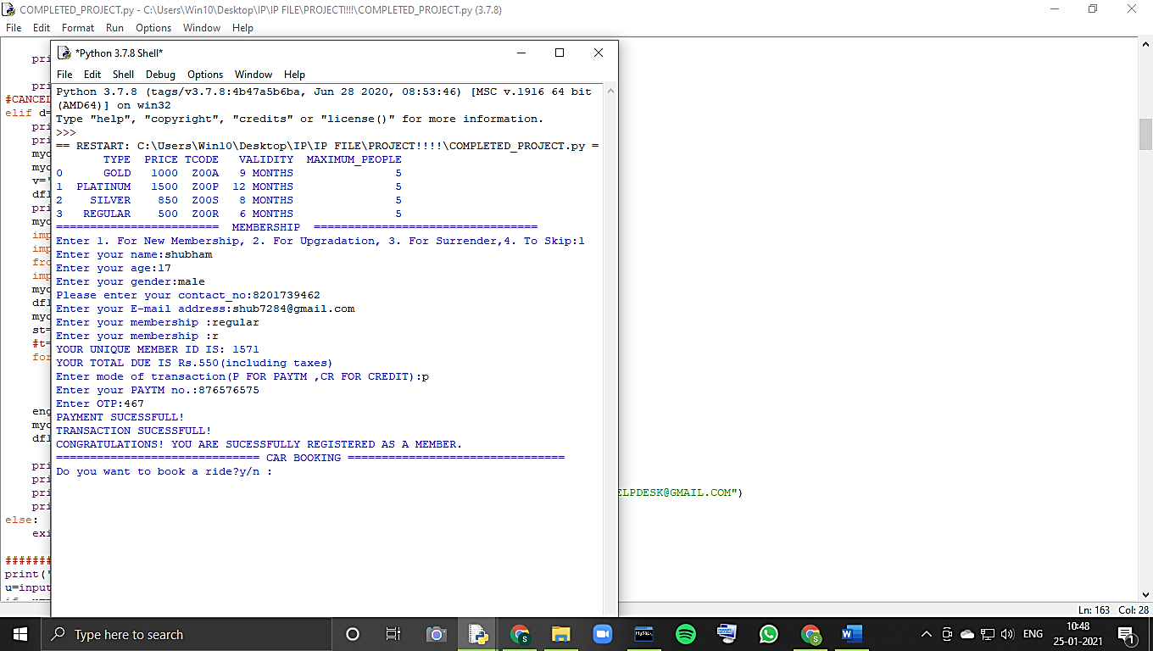

**If user wants to upgrade his existing membership:**

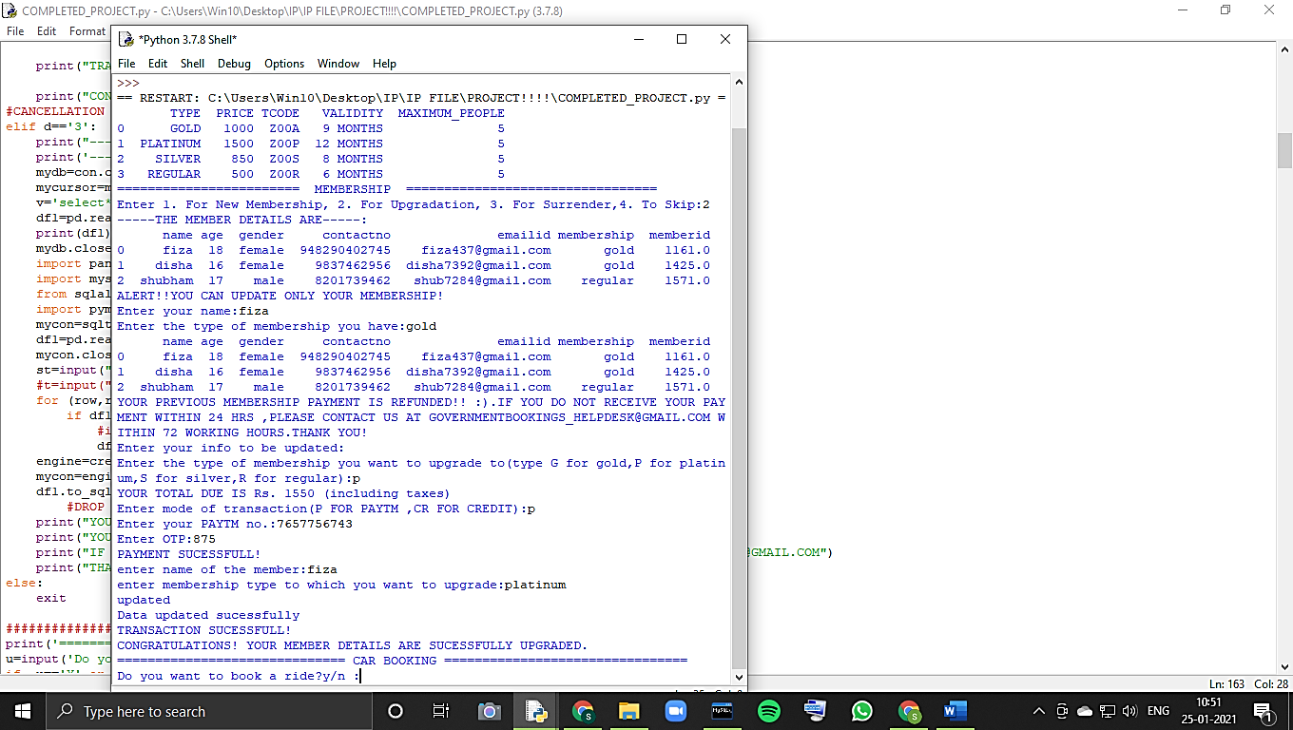

**If user wants to cancel it’s membership:**



**If the user don’t want to do anything related to membership:**



**When the user wants to book a ride:**

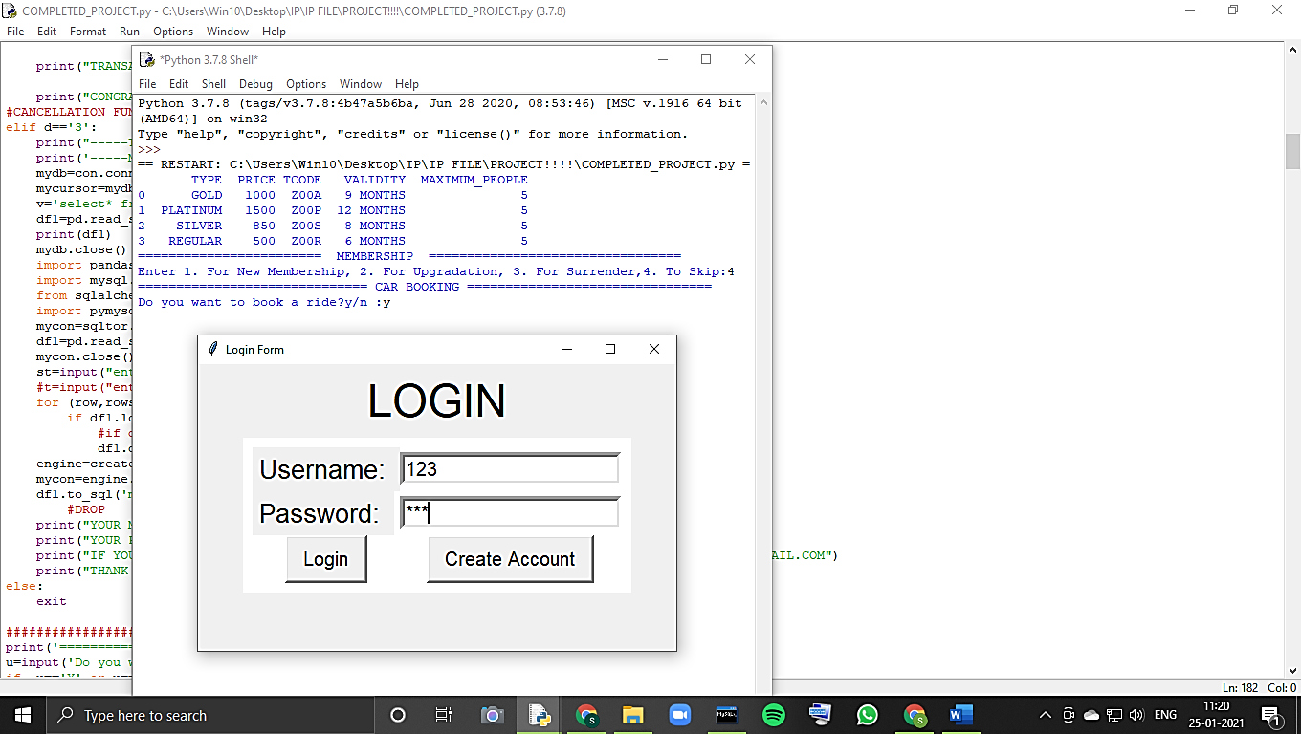

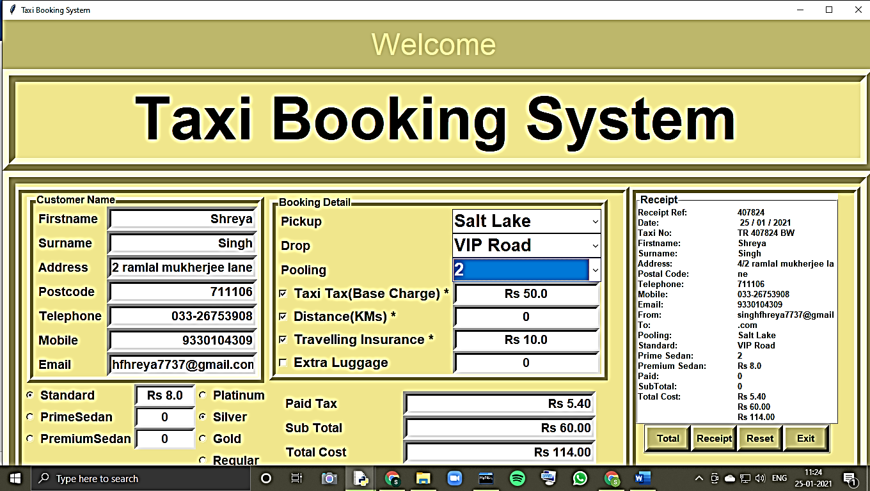

**When admin wants to upgrade its records:**



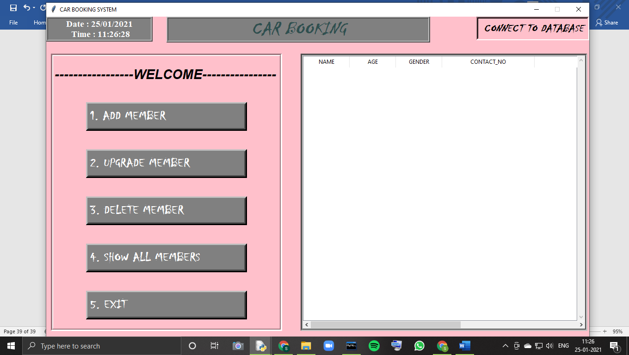

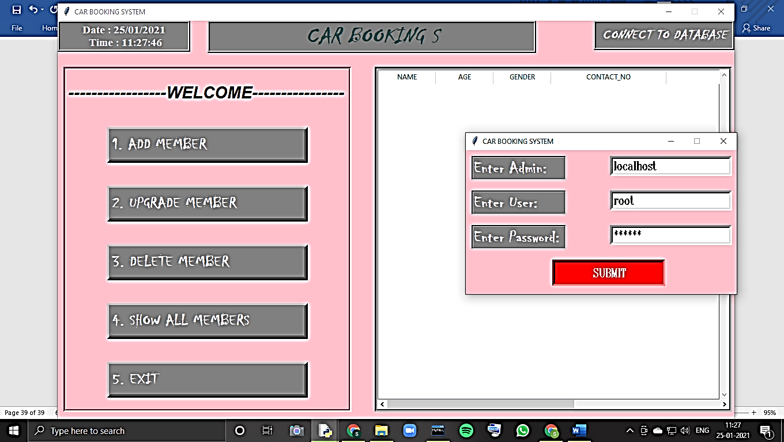

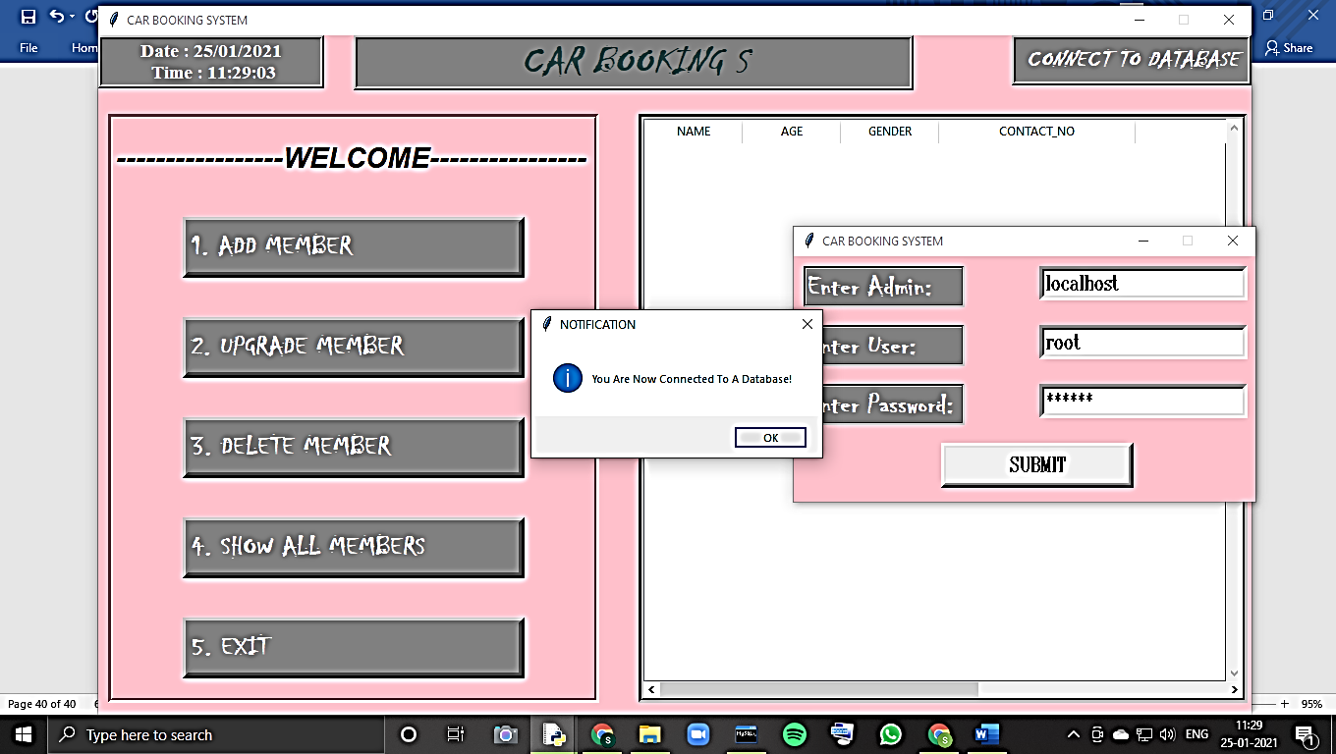

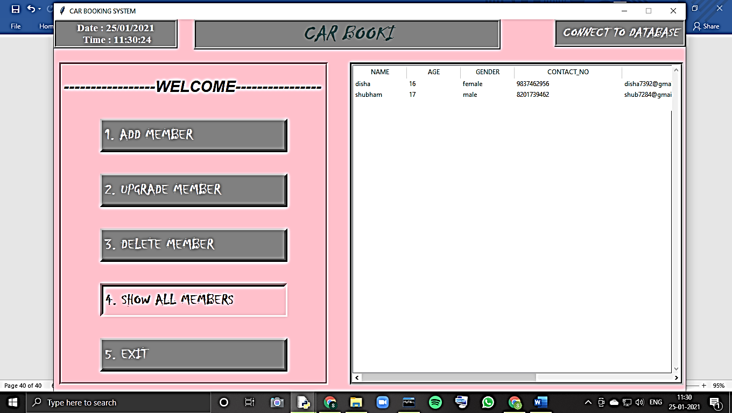

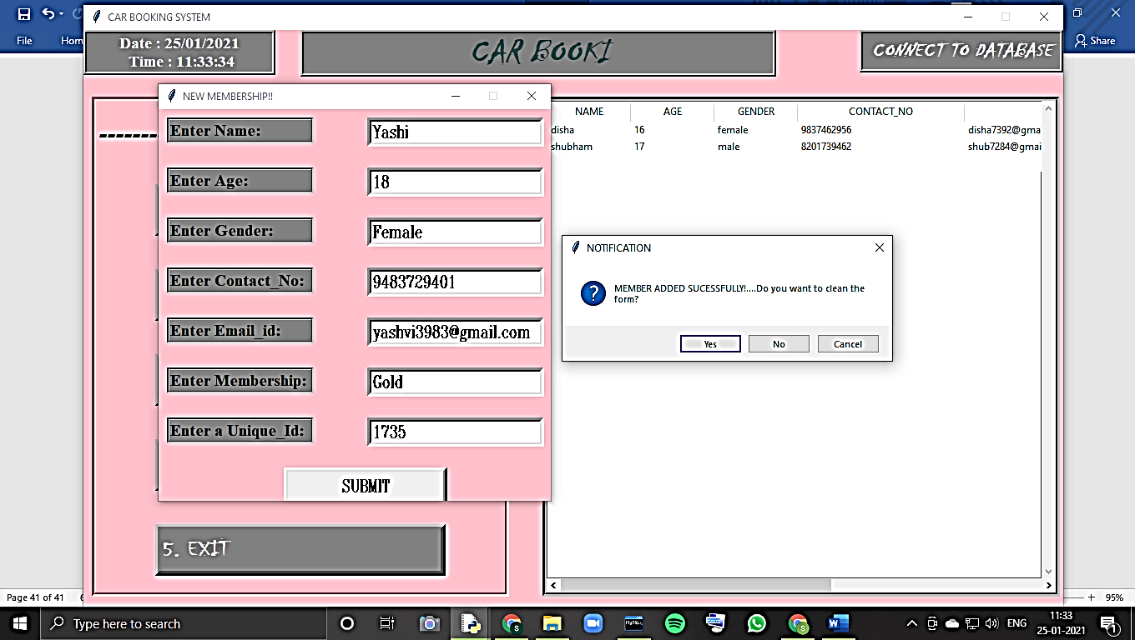

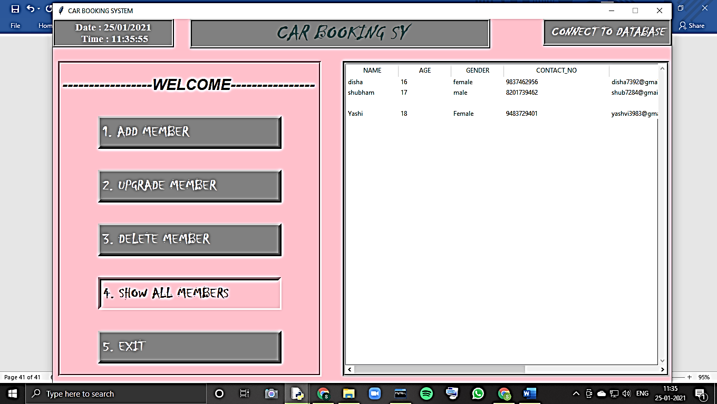

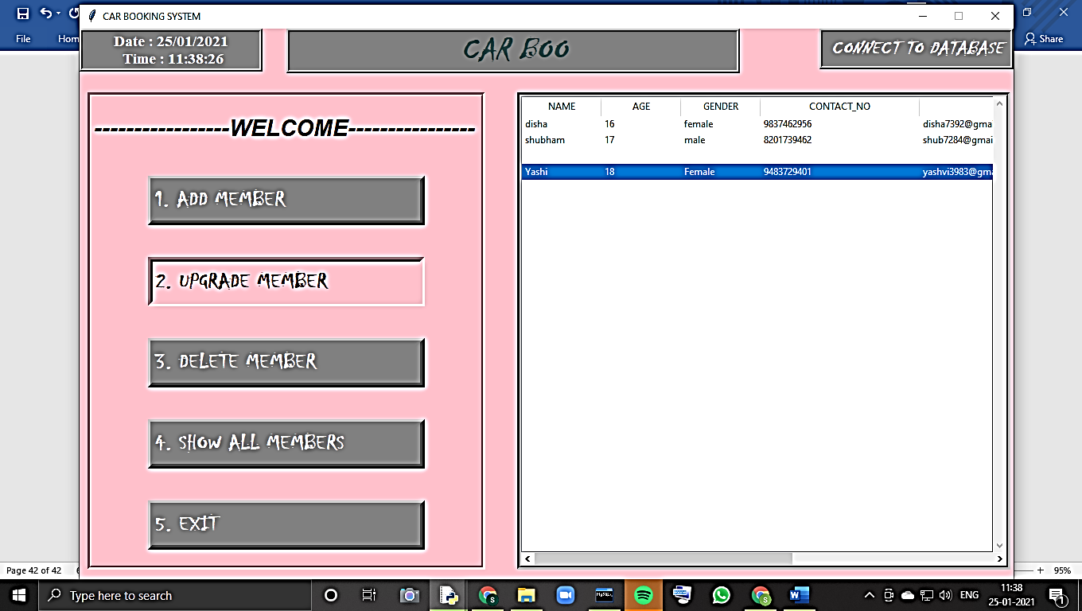

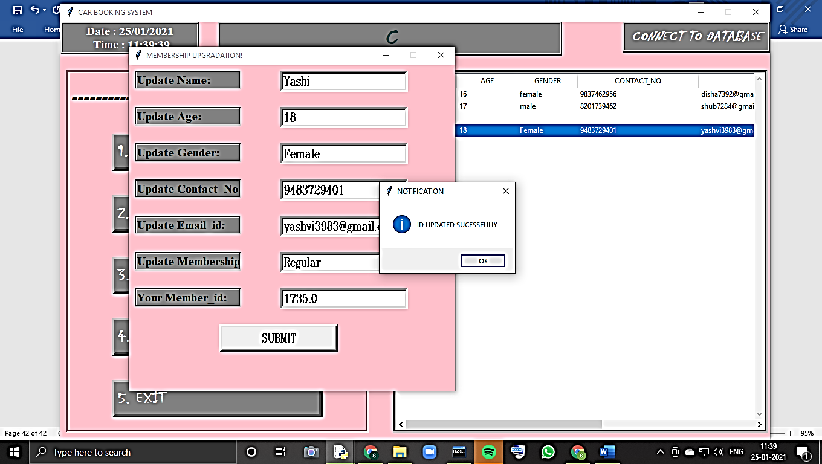

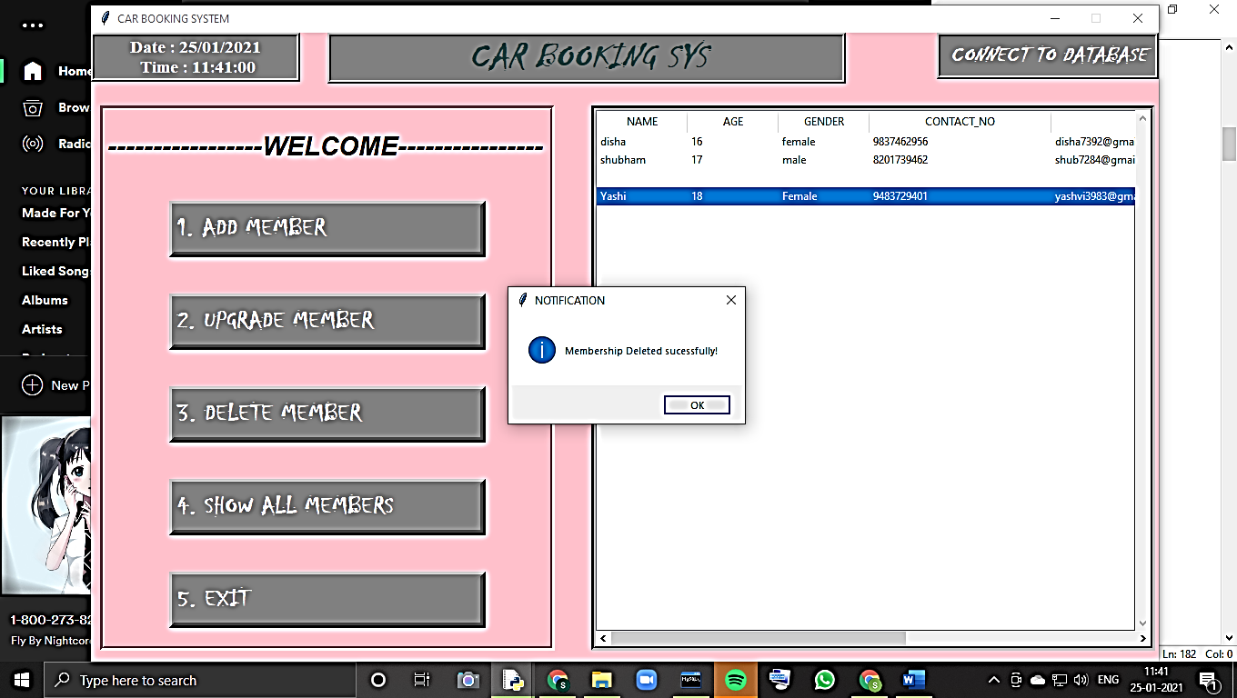

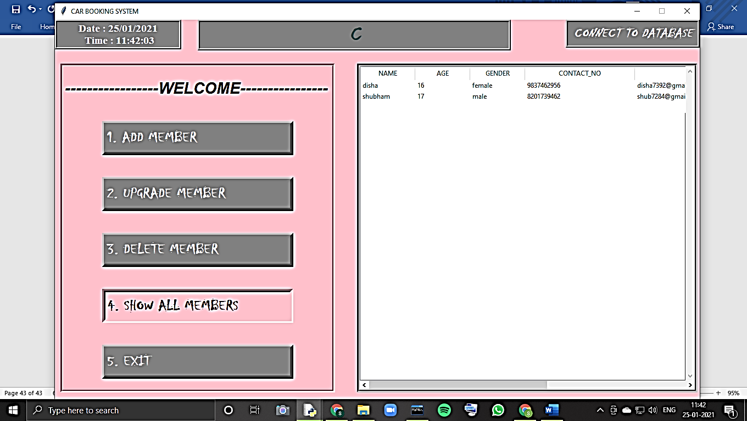

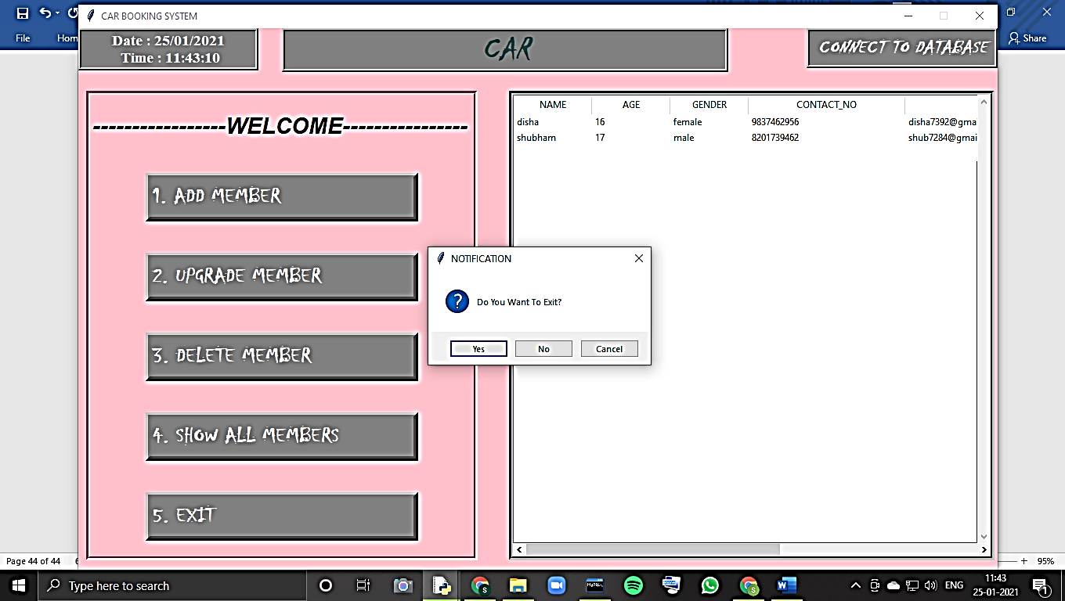

**When the user wants to see previous records to the company:**

1.Performance through the years:

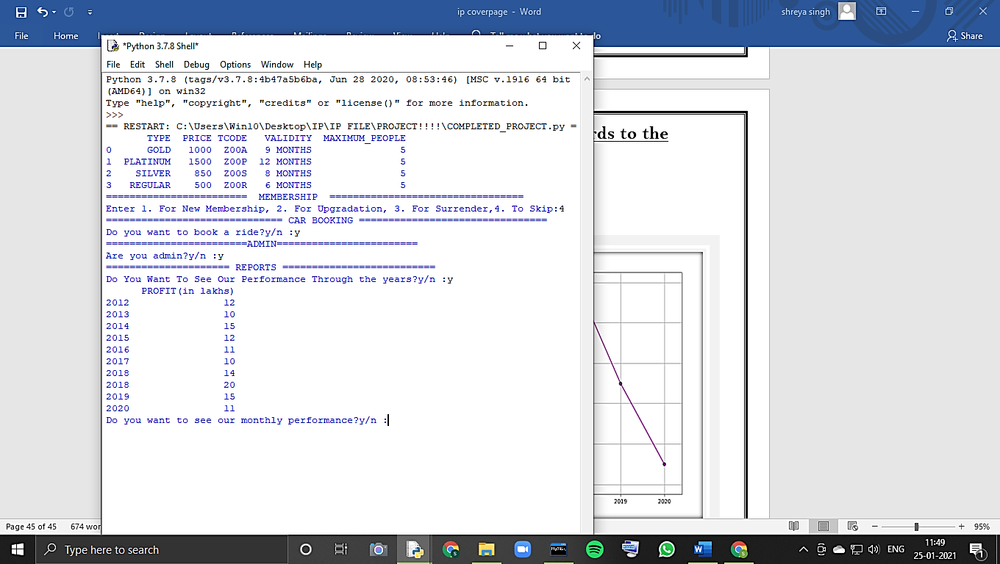

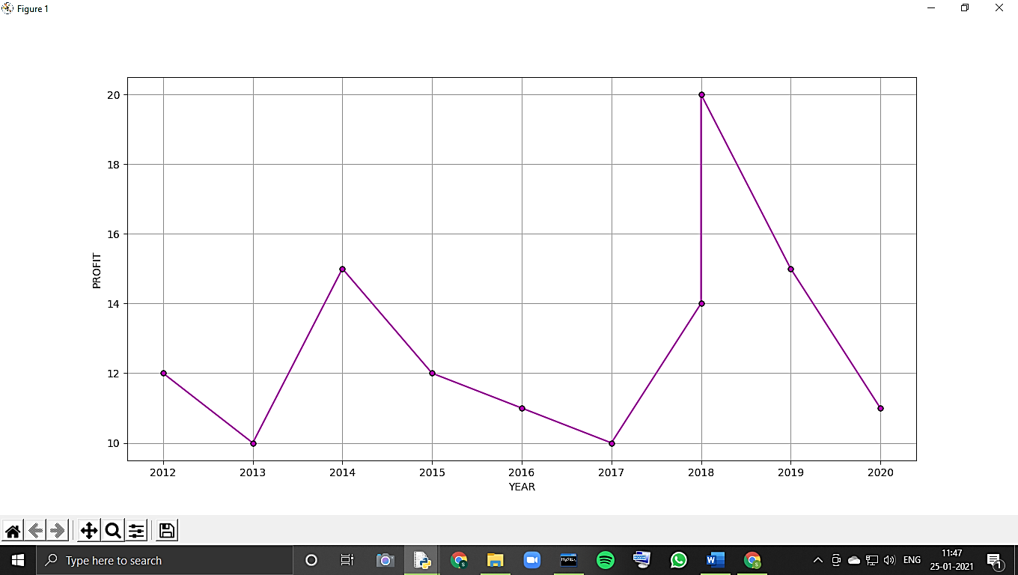

2.Monthly Performance:

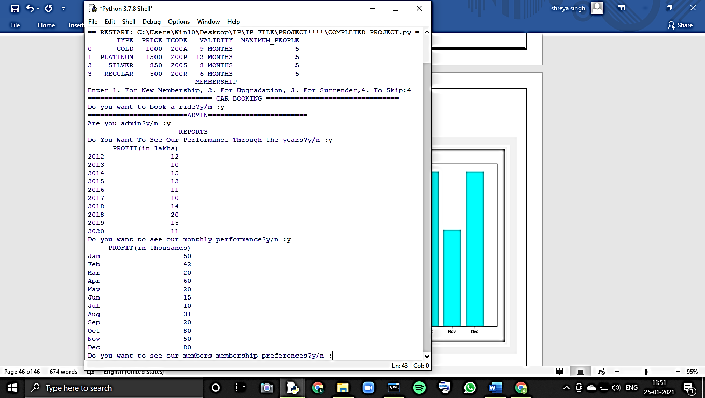

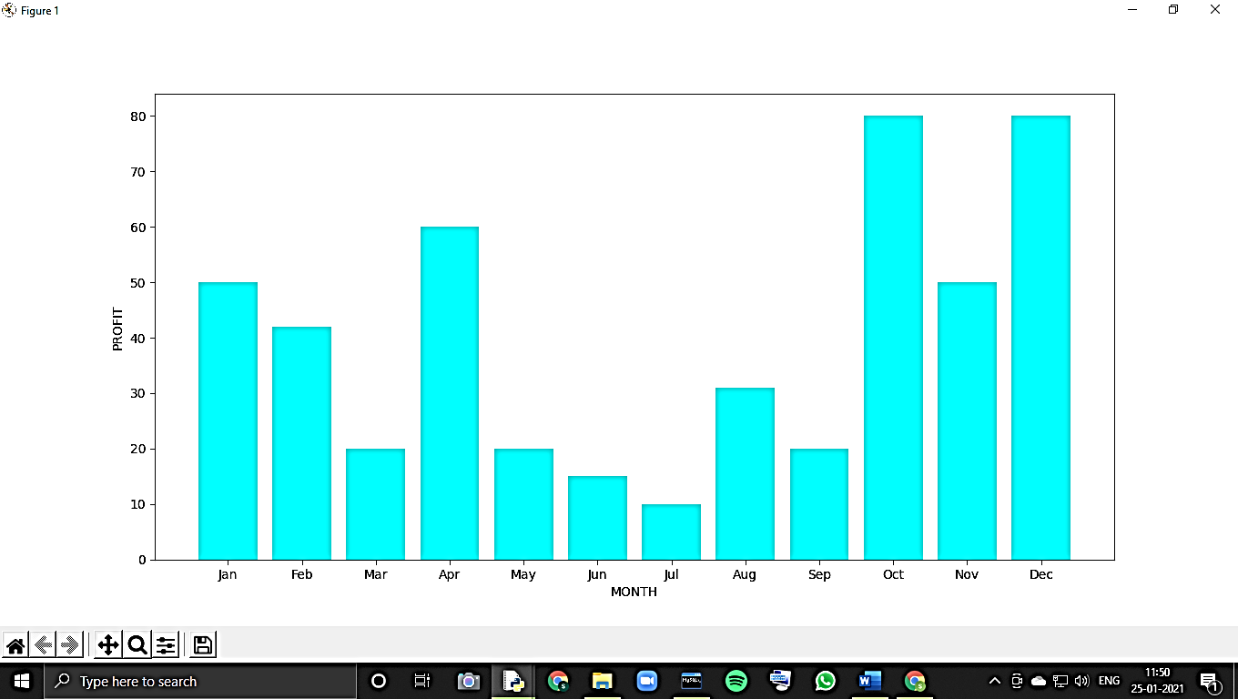

3.Membership Preferences:

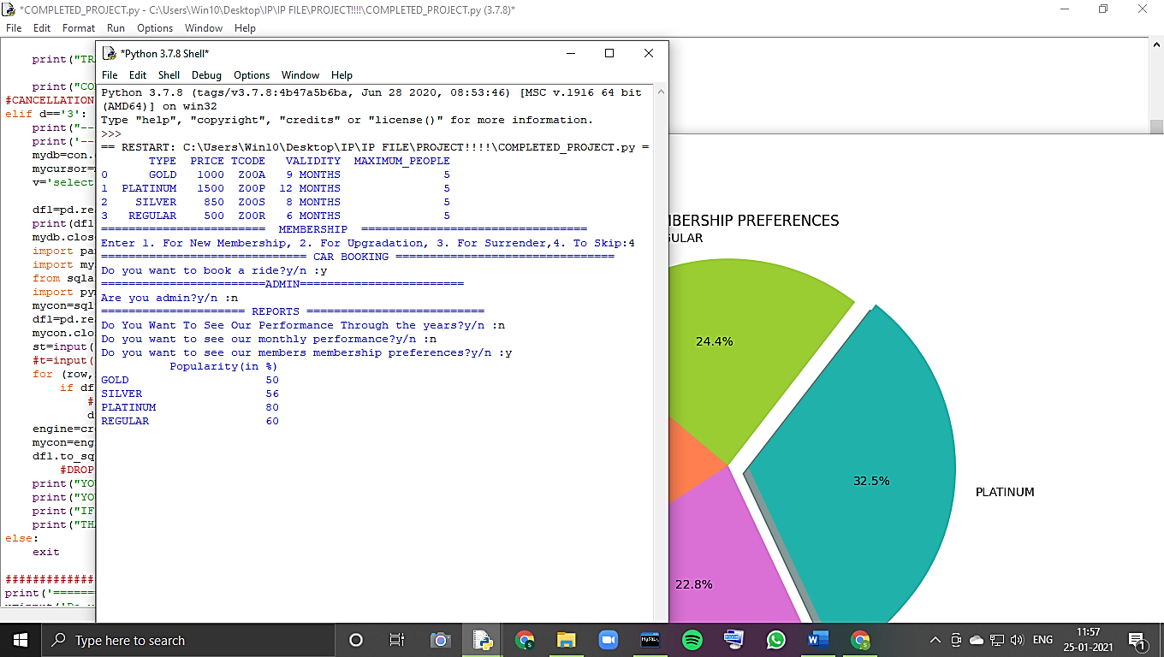

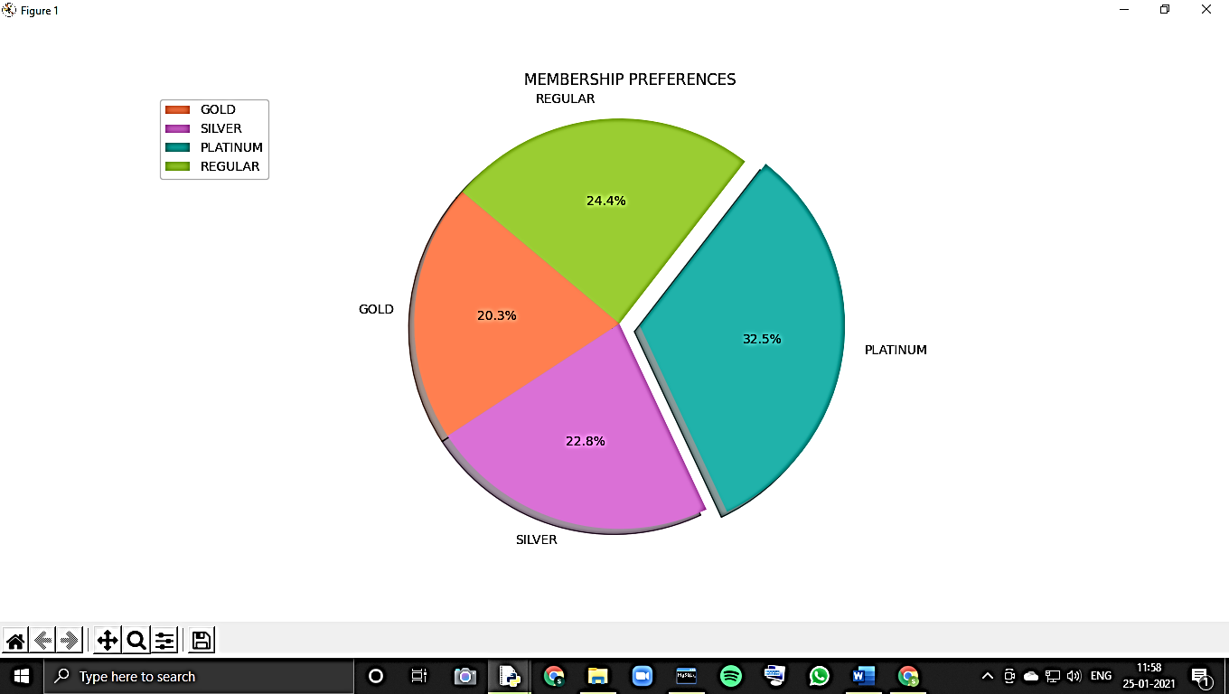

4.Car Preferences:

